Internal verification of assessment decisions – BTEC Higher Nationals (RQF)

INTERNAL VERIFICATION – ASSESSMENT DECISIONS (Single Student)
Programme Title: |  | HND in Computing
Unit Number and Title: |  | 20. Applied Programming and Design Principles
Assessor Name: |  | Ms. ALF. Sajeetha |  | Internal Verifier Name:
Assignment title: |  | Delta Transit Authority (DTA) Passenger Analytical Tool
Name of student | Submission Type  (First, Resubmission, Retake) | Grade the Assessor has awarded. | Assessment Decision Accurate (Y/N)  (Resubmission and retake must be capped at a Pass) | List the learning outcomes and grading criteria where inaccurate decisions have been made |  | State why the assessment decision is inaccurate.  *If an inaccurate decision is recorded the Internal Verifier must recommend actions detailing the issues to be addressed. The Assessor and the Internal Verifier must then confirm that the action has been undertaken before assessment decisions are issued to the student.
INTERNAL VERIFIER CHECKLIST |  |  |  |  |  |  | Y/N
Has the student and the Assessor confirmed the authenticity of the evidence?
Is there evidence of collusion or plagiarism? The work submitted for assessment has been carried out without assistance other than that which is acceptable according to the rules of the specification. The evidence submitted for this assignment is student’s own. The student has clearly referenced any sources and any artificial intelligence (AI) tools used in the work.
Is the assessor feedback to the student appropriate and constructive to each student? Provide comments below.
- Points out strengths and areas for improvement.
- Linked to relevant learning outcomes and assessment criteria.
- Clear as to why the student did not achieve higher grades.
- Identify opportunities for improved performance in future assignments.
GENERAL COMMENTS
Any actions required must be reviewed across the whole cohort.
Action Required |  |  |  |  | Target Date for Completion |  |  | Date Action Completed
I confirm that the assessment decisions are accurate, there is no evidence of assessment malpractice and any action points have been addressed and completed in respect of the whole cohort. I declare the work submitted for assessment has been carried out without assistance other than that which is acceptable according to the rules of the specification. The evidence submitted for this assignment is student’s own. The student has clearly referenced any sources and any artificial intelligence (AI) tools used in the work.
Internal Verifier signature |  |  |  |  | Date
Assessor signature |  |  |  |  | Date

Higher Nationals - Summative Assignment Feedback Form

Student Name/ID | MN. Sihanas / 1030371
Unit Title | Applied Programming and Design Principles
Assignment Number | Assignment 01 | Assessor | Ms. ALF. Sajeetha
Submission Date | 26.08.2025 | Date Received 1st submission
Re-submission Date |  | Date Received 2nd submission
Assessor Feedback:

*Please note that constructive and useful feedback should allow students to understand:

- Strengths of performance
- Limitations of performance
- Any improvements needed in future assessments

Feedback should be against the learning outcomes and assessment criteria to help students understand how these inform the process of judging the overall grade.

Feedback should give full guidance to the students on how they have met the learning outcomes and assessment criteria.
I certify that to the best of my knowledge the evidence submitted for this assignment is the student’s own. The student has clearly referenced any sources and any artificial intelligence (AI) tools used in the work. I have not solely used AI to grade the student’s work.

Grade: | Assessor Signature: |  | Date:
Resubmission Feedback:
*Please note resubmission feedback is focussed only on the resubmitted work
Grade: | Assessor Signature: |  | Date:
Internal Verifier’s Comments:
Signature & Date:

* Please note that grade decisions are provisional. They are only confirmed once internal and external moderation has taken place and grades decisions have been agreed at the assessment board.
Pearson Education 2016
Higher Education Qualifications
Internal Verification of Assignment Brief

Student Assessment Submission and Declaration
When submitting evidence for assessment, each student must sign a declaration confirming that the work is their own.
Student name:  MN. Sihanas |  | Assessor name: Ms. ALF. Sajeetha
Issue date:  26.06.2025 | Submission date:  26.08.2025 |  | Submitted on:  26.08.2025
Programme:
HND in Computing
Unit: Programming
Assignment number and title: Delta Transit Authority (DTA) Passenger Analytical Tool
Plagiarism
Plagiarism is a particular form of cheating. Plagiarism must be avoided at all costs and students who break the rules, however innocently, may be penalised. It is your responsibility to ensure that you understand correct referencing practices. As a university level student, you are expected to use appropriate references throughout and keep carefully detailed notes of all your sources of materials for material you have used in your work, including any material downloaded from the Internet. Please consult the relevant unit lecturer or your course tutor if you need any further advice.

Student Declaration
Student declaration
I certify that the assignment submission is entirely my own work and I fully understand the consequences of plagiarism. I declare that the work submitted for assessment has been carried out without assistance other than that which is acceptable according to the rules of the specification. I certify I have clearly referenced any sources and any artificial intelligence (AI) tools used in the work. I understand that making a false declaration is a form of malpractice.

Student signature: Date:

General Guidelines

- A Cover page or title page – You should always attach a title page to your assignment. Use previous page as your cover sheet and make sure all the details are accurately filled.
- Attach this brief as the first section of your assignment.
- All the assignments should be prepared using a word processing software.
- All the assignments should be printed on A4 sized papers. Use single side printing.
- Allow 1” for top, bottom, right margins and 1.25” for the left margin of each page.

Word Processing Rules

- The font size should be 12 poin, and should be in the style of Time New Roman.
- Use 1.5 line spacing. Left justify all paragraphs.
- Ensure that all the headings are consistent in terms of the font size and font style.
- Use footer function in the word processor to insert Your Name, Subject, Assignment No, and Page Number on each page. This is useful if individual sheets become detached for any reason.
- Use word processing application spell check and grammar check function to help editing your assignment.

Important Points

- It is strictly prohibited to use text boxes to add texts in the assignments, except for the compulsory information. eg: Figures, tables of comparison etc. Adding text boxes in the body except for the before mentioned compulsory information will result in rejection of your work.
- Avoid using page borders in your assignment body.
- Carefully check the hand in date and the instructions given in the assignment. Late submissions will not be accepted.
- Ensure that you give yourself enough time to complete the assignment by the due date.
- Excuses of any nature will not be accepted for failure to hand in the work on time.
- You must take responsibility for managing your own time effectively.
- If you are unable to hand in your assignment on time and have valid reasons such as illness, you may apply (in writing) for an extension.
- Failure to achieve at least PASS criteria will result in a REFERRAL grade.
- Non-submission of work without valid reasons will lead to an automatic RE FERRAL. You will then be asked to complete an alternative assignment.
- If you use other people’s work or ideas in your assignment, reference them properly using HARVARD referencing system to avoid plagiarism. You have to provide both in-text citation and a reference list.
- If you are proven to be guilty of plagiarism or any academic misconduct, your grade could be reduced to A REFERRAL or at worst you could be expelled from the course.

Unit 20: Applied Programming and Design Principles
Assignment Brief
Programme Title
Student Name/ID Number | MN. Sihanas / 1030371
Unit Number and Title | Unit 20: Applied Programming and Design Principles
Academic Year
Unit Tutor | Ms. ALF. Sajeetha
Assignment Title | Delta Transit Authority (DTA) Passenger Analytical Tool
Issue Date | 26.06.2025
Submission Date | 26.08.2025
Submission Format
The submission should be in the form of an individual report written in a concise, formal business style using single spacing and font size 12. You are required to make use of headings, paragraphs and subsections as appropriate, and all work must be supported with research and referenced using Harvard referencing system. Please also provide an end list of references using the Harvard referencing system.
The recommended word count is 5,000–5,500 words for the report excluding annexures, although you will not be penalised for exceeding the total word limit.

Unit Learning Outcomes
LO1 Investigate the impact of SOLID development principles on the
OOP paradigm.

LO2 Design a large dataset processing application using SOLID principles
and clean coding techniques

LO3 Build a data processing application based on a developed design.

LO4 Perform automatic testing on a data processing application.

Transferable skills and competencies developed
Python Frameworks of Desktop GUI development, Automation Python Unit Testing Tool
Vocational scenario - Delta Transit Authority (DTA) Passenger Analytical tool

Delta Transit Authority (DTA) is a leading public transportation provider in a major Delta city, serving millions of passengers daily across subway, bus, and commuter rail systems. With a vast network of stations and routes, DTA collects massive amounts of data from turnstiles, mobile ticketing apps, and payment systems.
Currently, the DTA uses a computerized system to record daily passenger entries and exits, route selections, and ticket purchases, storing all data in a centralized database. Every quarter, the DTA management team analyzes this passenger data to make decisions about service planning, resource allocation, and infrastructure upgrades.
However, the current data analysis process is manual, leading to several challenges such as human bias, limited analytical scope, slow turnaround, high error rates, increased costs, and poor reproducibility. Recognizing these issues, DTA’s top management has decided to commission a computer-based solution for passenger data analysis.
You are a lead software engineer at Urban Data Solutions (UDS) Ltd, a leading software development firm specializing in large-scale analytics. DTA’s management has contracted UDS to develop a standalone desktop application for passenger data analysis. The application must be built using Python Framework and should provide a GUI for user interaction. Several large, real-world sample datasets are available at the following sources, which you should use for development and testing.
- National Transit Database (NTD) (FTA)
https://www.transit.dot.gov/ntd
- MTA Ridership and Transit Data (Data.gov)
https://catalog.data.gov/dataset/?tags=passengers , https://catalog.data.gov/dataset/?tags=passengers
- Public Transportation Passenger Counts (Kaggle) https://www.kaggle.com/datasets/ifuurh/public-transportation-passenger-counts

Using above sources, implement chunk-based processing for large files (5GB+) including robust error handling and a dead-letter queue for problematic records and build a modular, extensible pipeline using object-oriented programming principles, including,
- Source-agnostic data ingestion (support for CSV, JSON, Database or APIs)
- Chainable data transformations (filtering, aggregation, enrichment)
- Multi-format output (Graph, Forms or CSV)
The DTA management expects the following results from your computer-based passenger data analysis application,
- Peak Congestion Analysis:
Passenger data should help identify the times and stations with the highest congestion. This information will be used to optimize train and bus schedules, allocate resources, and improve passenger flow. (Analysis by hour, day, month, and year.)
- Popular Route and transfer point Analysis:
The application should analyze passenger flow to determine the most frequently used routes and transfer points. This will inform service planning and marketing strategies.
- Service Disruption Detection:
By analyzing anomalies in passenger flow, the system should help detect potential service disruptions or unusual patterns that may indicate operational issues.
- Regional Performance Analysis:
The application should provide insights into passenger trends across different regions or boroughs, enabling targeted improvements and investments.

Assignment activity and guidance
PART 1
By evaluating the impact of SOLID development principles on object-oriented application development. You should consider the following areas in preparing that report,
Investigation about Principles of object-oriented paradigm, Class relationships with coding examples.
Analysis in different types of design patterns with coding examples.
Explanation about clean coding techniques and the impact of clean coding techniques on the use of data structures and their operations in writing algorithms.
Evaluation about the impact of SOLID development principles on object-oriented application development using appropriate coding examples.

Part 2

Prepare a design document to design a large dataset processing application (Low level Structural Design of the Application using UML) for the given scenario. You should consider the following areas in preparing that document,
Explanation about utilization of solid principles, clean coding techniques and design patterns in the proposed application.
Explanation about how the design of the proposed application is refined to include multiple design patterns.
Design of the test plan (testing regime) for the proposed application by including a provision for automated testing.
Test Plan Template

Part 3

Build (develop) the proposed data processing application using Python programming language. Prepare a report by providing the screenshots of the source codes and user interfaces as evidence and assessing the effectiveness of using SOLID principles, clean coding techniques and programming design patterns on the application developed. (Attach the source code)

Part 4
Perform automated testing on the developed application. You are required to prepare a report about that automated testing by considering following areas,
Examination about the different methods of implementing automatic testing as designed in the test plan.
Screenshots of the implemented automated testing as evidence.
Discussion about the differences between developer-produced and vendor-provided automatic testing tools for applications and software systems.
Analysis about the benefits and drawbacks of different forms of automatic testing of applications and software systems, with examples from your developed data processing application. (Ex: Binary searching algorithm python coding – unit testing)

Recommended Resources
Please note that the resources listed are examples for you to use as a starting point in your research – the list is not definitive.

Learning Outcomes and Assessment Criteria
 | Pass | Merit | Distinction
 | LO1 Investigate the impact of SOLID development principles on the OOP paradigm
 | P1 Investigate the characteristics of the object orientated paradigm, including class relationships and SOLID principles.  P2 Explain how clean coding techniques can impact on the use of data structures and operations when writing algorithms. | M1 Analyse, with examples, each of the creational, structural and behavioural design pattern types. | D1 Evaluate the impact of SOLID development principles on object orientated application development.
 | LO2 Design a large dataset processing application using SOLID principles and clean coding techniques
 | P3 Design a large data set processing application, utilising SOLID principles, clean coding techniques and a design pattern.  P4 Design a suitable testing regime for the application, including provision for automated testing. | M2 Refine the design to include multiple design patterns
LO3 Build a data processing application based on a developed design
P5 Build a large dataset processing application based on the design produced |  | M3 Assess the effectiveness of using SOLID principles, clean coding techniques and programming patterns on the application developed. | D2 Analyse the benefits and drawbacks of different forms of automatic testing of applications and software systems, with examples from the developed application
LO4 Perform automatic testing on a data processing application
P6 Examine the different methods of implementing automatic testing as designed in the test plan.  P7 Implement automatic testing of the developed application. |  | M4 Discuss the differences between developer produced and vendor provided automatic testing tools for applications and software systems.

Acknowledgement
I would like to express my sincere gratitude to all those who supported me throughout the completion of this assignment. First and foremost, I extend my deepest appreciation to my assessor, Mrs. ALF. Sajeetha, for her valuable guidance, encouragement, and constructive feedback, which were instrumental in shaping this work.

I am also thankful to my lecturers and the faculty of BCAS Campus, whose continuous teaching and support provided me with the knowledge and resources required to carry out this project successfully.

A special thanks goes to my peers and colleagues who contributed with their feedback during the design and evaluation stages of the user interface, enabling me to refine the system based on real user perspectives. Their insights were crucial in making this project more practical and user-centered.

Finally, I would like to acknowledge my family for their patience, understanding, and constant encouragement, which motivated me to stay focused and complete this work to the best of my ability.

Table of Content
Introduction 1
Part 1 2
1.1 Investigation about Principles of Object-Oriented Paradigm and Class Relationships 2
1.1.1 Principles of Object-Oriented Paradigm 2
1.1.2 Class Relationships in OOP 6
1.2 Analysis of Different Types of Design Patterns with Coding Examples 9
1.2.1 Creational Design Patterns 9
1.2.2 Structural Design Patterns 11
1.2.3 Behavioural Design Patterns 14
1.3 The impact of clean coding techniques on the use of data structures and operations when writing algorithms 16
1. Meaningful Naming 16
1.4 Evaluation on the Impact of SOLID Principles in Object-Oriented Application Development 23
1.4.1. Single Responsibility Principle (SRP) 23
1.4.2. Open–Closed Principle (OCP) 24
1.4.3. Liskov Substitution Principle (LSP) 25
1.4.4. Interface Segregation Principle (ISP) 26
1.4.5. Dependency Inversion Principle (DIP) 27
Part 2 28
2.1 Utilization of SOLID Principles, Clean Coding Techniques, and Design Patterns in the Proposed Application 28
2.1.1 Utilization of SOLID Principles 28
2.1.2 Utilization of Clean Coding Techniques 30
3.1.3 Utilization of Design Patterns 31
2.2 Explanation about how the design of the proposed application is refined to include multiple design patterns. 32
2.3 Designing a test plan (testing regime) for the proposed application by including a provision for automated testing. 35
2.3.1 Testing Strategies 35
2.3.2 Test Plan for the Proposed Application 35
Part 3 38
3.1 Source Code of the Developed System with evidence. 38
3.1.1 Core Abstractions 38
3.1.2 Data Access & Preprocessing 40
3.1.3 Search & Filtering Orchestration 41
3.1.4 Analytical Modules 42
3.1.5 Application Orchestration 50
1.3.6 Entry Point 58
3.2 Interface overview of the Developed System with evidence. 59
3.2.1 Sidebar Filters 59
3.2.2 Overview Metrics Section 60
3.2.6 Regional Performance analysis Tab 65
3.3 Assessment of SOLID Principles, Clean Code Practices, and Design Patterns 66
3.3.1 Application of SOLID Principles 66
3.3.2 Clean Code Practices 67
3.3.3 Use of Design Patterns 68
Part 4 69
4.1 Examination of Automated Testing Methods 69
4.1.1 Unit Testing: 69
4.1.2 Integration Testing: 71
4.1.3 Mocking and Stubbing: 72
4.1.4 Error Handling Tests: 73
4.1.5 Coverage Measurement: 73
4.2 Evidence of Implemented Automated Testing 74
4.2.1 Pytest Execution Results: 74
4.2.2 Coverage Report: 75
4.3 Discussion on Developer-Produced vs Vendor-Provided Automatic Testing Tools 77
4.3.1 Developer-Produced Testing Tools 77
4.3.2 Vendor-Provided Testing Tools 78
4.3.3 Comparative Analysis 79
4.4 Analysis of the Benefits and Drawbacks of Different Forms of Automatic Testing 80
4.4.2 Integration Testing 81
4.4.3 Mocking and Stubbing 82
4.4.4 Coverage Testing 82
4.4.5 Comparative Summary of Benefits and Drawbacks of Different Forms of Automatic Testing 83
Conclusion 84
References 85

List of Figure
Figure 1: coding example for Abstraction 3
Figure 2: Coding example for Encapsulation 4
Figure 3: Coding example for Inheritance 4
Figure 4: Coding example for Polymorphism 5
Figure 5: Coding example for Association class relationship 6
Figure 6: Coding example for Aggregation class relationship 7
Figure 7: Coding example for Composition class relationship 7
Figure 8: Coding example for Dependency class relationship 8
Figure 9: Coding example for Generalization (Inheritance) class relationship 8
Figure 10: Coding example for singleton method design pattern 9
Figure 11: Coding example for factory method design pattern 10
Figure 12: Coding example for Adapter method Design pattern 11
Figure 13: Coding example for Façade method design pattern 12
Figure 14: Coding example for Strategy method design pattern 14
Figure 15: Coding example for Template method design pattern 15
Figure 16: Before using Meaningful Naming technique 16
Figure 17: after using Meaningful naming technique 16
Figure 18: Before using Single Responsibility Principle (SRP) 17
Figure 19: after using Single Responsibility Principle (SRP) 17
Figure 20: before using Consistent Formatting and Code Structure 18
Figure 21: after using Consistent Formatting and Code Structure 18
Figure 22: before using Modularity and Reusability 19
Figure 23: after using Modularity and Reusability 19
Figure 24: before using Error Handling and Robustness 19
Figure 25: after using Error Handling and Robustness 20
Figure 26: before using Avoiding Code Duplication 20
Figure 27: after using Avoiding Code Duplication 21
Figure 28: before using Readability and Documentation 21
Figure 29: after using Readability and Documentation 22
Figure 30: Coding example for Single Responsibility Principle (SRP) 23
Figure 31: Coding example for Open–Closed Principle (OCP) 24
Figure 32: Coding example for Liskov Substitution Principle (LSP) 25
Figure 33: Coding example for Interface Segregation Principle (ISP) 26
Figure 34: Coding example for Dependency Inversion Principle (DIP) 27
Figure 35: UML class diagram before refinements 28
Figure 36: UML class diagram after the refinements 34
Figure 37: DataAnalyzer class 38
Figure 38: DataFilter class 38
Figure 39: TimeFilter Class 39
Figure 40: RegionFilter class 39
Figure 41: RouteFilter class 39
Figure 42: DataProcessor class 40
Figure 43: SearchEngine class 41
Figure 44: CongestionAnalyzer class 1 42
Figure 45: CongestionAnalyzer class 2 43
Figure 46: RouteAnalyzer class 1 44
Figure 47: RouteAnalyzer class 2 45
Figure 48: DisruptionAnalyzer class 1 46
Figure 49: DisruptionAnalyzer class 2 47
Figure 50: RegionalAnalyzer class 1 48
Figure 51: RegionalAnalyzer class 2 49
Figure 52: BusPassengerAnalysisApp 50
Figure 53: load_data function 51
Figure 54: create_sidebar_filters function 51
Figure 55: apply_filters function 52
Figure 56: display_overview_metrics function 53
Figure 57: run function 54
Figure 58: run function tab 1 55
Figure 59: run function tab 2 55
Figure 60: run function tab 3 56
Figure 61: run function tab 4 57
Figure 62: run function tab 5 58
Figure 63: main function 58
Figure 64: sidebar (interface) 59
Figure 65: Dashboard overview (interface) 60
Figure 66: Peak Congestion Analysis tab (interface) 61
Figure 67: Route analysis tab (interface) 1 62
Figure 68: Route analysis tab (interface) 2 63
Figure 69: Disruption Detection analysis Tab (interface) 1 64
Figure 70: Disruption Detection analysis Tab (interface) 2 64
Figure 71: Regional Performance analysis tab (interface) 65
Figure 72: DataProcessor pytest 69
Figure 73: TimeFilter pytest 70
Figure 74: End-to-End Pipeline pytest 71
Figure 75: Mocking Streamlit Page Config pytest 72
Figure 76: File Not Found (error handling) pytest 73
Figure 77: coverage measurement pytest 73
Figure 78: pytest execution 74
Figure 79: pytest result (all passed) 74
Figure 80: function coverage report 75
Figure 81: class coverage report 76
Figure 82: unit testing example from the developed application 80
Figure 83: integration testing example from the developed application 81
Figure 84: Mocking and Stubbing example from the developed application 82
Figure 85: Comparative Summary of Benefits and Drawbacks of Different Forms of Automatic Testing 83

List of Table

Table 1: Testing Schedule 37
Table 2: Application of SOLID Principles 66
Table 3: Clean Code Practices 67
Table 4: Use of Design Patterns 68
Table 5: comparison of Developer-Produced vs Vendor-Provided Automatic Testing Tools 79

Introduction

The Delta Transit Authority (DTA) has a critical need for a modern, efficient passenger data analysis tool to replace its current manual system. This report details the development of a desktop application, the DTA Passenger Analytical Tool, built to address the challenges of human bias, limited scope, and high error rates associated with manual data processing. The solution is built upon a foundation of robust software engineering principles, with a particular focus on object-oriented programming (OOP), clean coding techniques, and the SOLID principles. The application is designed to handle large datasets, providing crucial insights into peak congestion, popular routes, service disruptions, and regional performance.

This document will investigate the theoretical underpinnings of the design, including an analysis of relevant design patterns and automatic testing methodologies, before concluding with a reflection on the effectiveness of the principles applied.

Part 1

1.1 Investigation about Principles of Object-Oriented Paradigm and Class Relationships

1.1.1 Principles of Object-Oriented Paradigm
Object-Oriented Programming (OOP) is a software development paradigm that models real-world entities as objects containing both data (attributes) and behaviours (methods). Instead of writing one long sequence of procedural code, OOP organizes programs into small, reusable, and modular components. This makes complex applications easier to design, maintain, and extend over time (Alexander S Gillis, 2024).

The main advantages of OOP include:
- Improved code reusability through inheritance and polymorphism.
- Better data security through encapsulation.
- Enhanced flexibility and maintainability because changes in one class do not always affect others.
- Ability to model real-world problems naturally.

The four key principles of OOP are Abstraction, Encapsulation, Inheritance, and Polymorphism.

1. Abstraction
Abstraction is the process of hiding implementation details and exposing only the necessary functionality. This allows developers to work with high-level concepts rather than being burdened with low-level details. Abstraction reduces complexity by defining a common interface that multiple classes can follow. This also improves flexibility since new implementations can be added without changing the client code (Pankaj, 2022).

Example: In the application, the DataAnalyzer abstract base class defines what analyzers should do (analyze and visualize data), but not how they should do it. Each analyzer (Congestion, Route, Disruption, Regional) provides its own implementation.
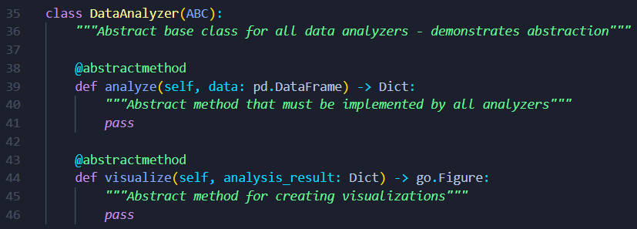
Figure 1: coding example for Abstraction

This ensures consistency across all analyzers while allowing each one to have different implementations. If tomorrow a new analyzer (e.g., “RevenueAnalyzer”) is added, it must follow the same interface without breaking the system.

2. Encapsulation
Encapsulation is the bundling of data (attributes) and methods (behaviours) into a single unit, while restricting direct access to the object’s internal state. Encapsulation protects data integrity by preventing unauthorized or accidental modification. It also provides controlled access through getters and setters (Sheldon, 2023).

Example: The DataProcessor class encapsulates the dataset. Raw data and processed data are stored in private attributes (_data and _processed_data) which cannot be accessed directly. Instead, the data property is used to safely retrieve it.
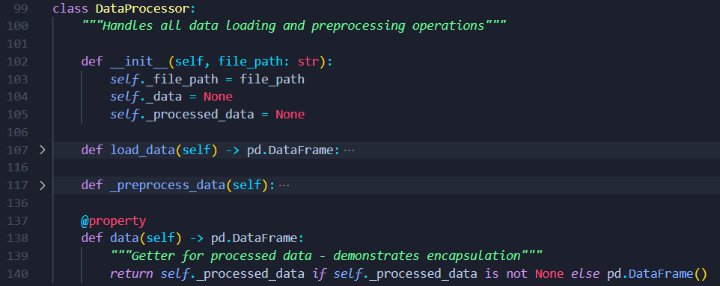
Figure 2: Coding example for Encapsulation

This ensures that other parts of the program cannot corrupt the raw dataset. Only valid, preprocessed data is made available, improving reliability and preventing runtime errors.
3. Inheritance
Inheritance allows one class (child/subclass) to acquire properties and methods from another class (parent/superclass). Inheritance promotes code reusability. Instead of writing the same code multiple times, common features are defined once in a parent class and reused across child classes (JANSSEN, 2017).

Example: The CongestionAnalyzer, RouteAnalyzer, DisruptionAnalyzer, and RegionalAnalyzer classes all inherit from the abstract base class DataAnalyzer. This ensures they all share the same structure but can implement their own logic.

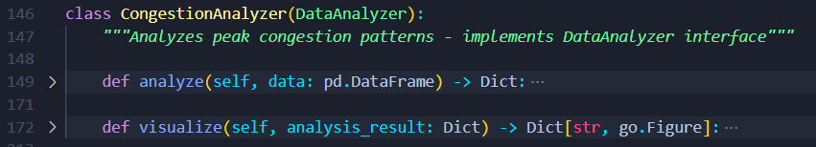
Figure 3: Coding example for Inheritance

This eliminates duplication. All analyzers automatically follow the same pattern, which makes the system extensible (new analyzers can be added easily) and consistent (all analyzers have analyze and visualize methods).
4. Polymorphism
Polymorphism allows the same interface or method to take different forms depending on the object that is using it. It simplifies code because the client does not need to know which specific class is being used; it only interacts with the common interface (Janssen, 2021).

Example: Although every analyzer implements the same methods (analyze and visualize), the logic inside these methods is different. The system just calls analyzer.analyze(data) and gets the correct result depending on which analyzer is active.

Figure 4: Coding example for Polymorphism

The application can dynamically switch between congestion, route, disruption, and regional analysis without changing the core logic. This makes the design flexible and future-proof.

1.1.2 Class Relationships in OOP
In object-oriented programming (OOP), the relationships between classes define how they interact and relate to each other. These connections are fundamental to building complex, well-structured, and maintainable software systems. Understanding these relationships helps in modelling real-world problems more accurately and creating code that is modular, reusable, and easy to manage.

The key class relationship types of OOP are association, aggregation, composition, dependency, and Generalization (Inheritance).

1. Association
Association is the most general and weakest relationship between two classes. It represents a "has a" or "uses a" connection where one class is related to another. The objects can exist independently of each other (Khan, 2023).

Example: BusPassengerAnalysisApp uses the SearchEngine class to perform filtering, but both can exist separately.

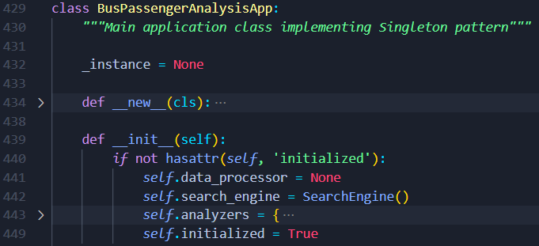
Figure 5: Coding example for Association class relationship

It promotes modularity since the search functionality can be improved or replaced without affecting the entire app.
2. Aggregation
Aggregation is a specific type of association that represents a "whole-part" relationship, where the "part" can exist independently of the "whole." It's a weaker form of a "has a" relationship. A key characteristic is that if the "whole" object is destroyed, the "part" objects are not (Khan, 2023).

Example: BusPassengerAnalysisApp aggregates analyzers like CongestionAnalyzer, RouteAnalyzer, etc. These analyzers exist independently but are grouped under the main app.

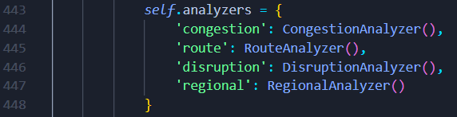
Figure 6: Coding example for Aggregation class relationship

3. Composition
Composition is a strong form of aggregation where the "part" objects cannot exist without the "whole" object. It's a "has a" relationship where the parts are dependent on the whole. When the "whole" object is destroyed, its "part" objects are also destroyed (Khan, 2023).

Example: The DataProcessor creates and manages _data and _processed_data. These objects are completely dependent on DataProcessor.

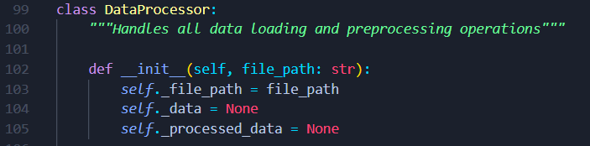
Figure 7: Coding example for Composition class relationship
It guarantees integrity of the data pipeline. If DataProcessor is destroyed, its internal data is also destroyed.
4. Dependency
Dependency means one class relies on another to perform its function. Dependency is a "uses a" relationship where one class depends on another. It means that a change in one class might affect another, but the relationship is not a structural one like association or aggregation. This often occurs when one class uses another as a parameter in a method (sözer, 2023).

Example: All analyze methods depend on a pandas.DataFrame input. Without the dataset, the analyzer cannot function.

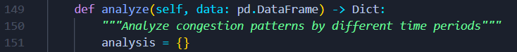
Figure 8: Coding example for Dependency class relationship
This makes analyzers flexible because they work with any dataset as long as it is provided in the right format.

5. Generalization (Inheritance)
Generalization is the process of defining common features in a parent class that are shared by child classes. Generalization, more commonly known as Inheritance, represents an "is a" relationship. It allows a new class (the subclass or child class) to inherit properties and behaviours from an existing class (the superclass or parent class). This promotes code reuse and creates a hierarchical structure (sözer, 2023).

Example: The DataAnalyzer class generalizes all analyzer classes by defining the common interface (analyze, visualize).
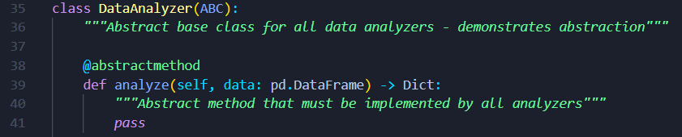
Figure 9: Coding example for Generalization (Inheritance) class relationship
This reduces duplication and enforces a standard design across analyzers.

1.2 Analysis of Different Types of Design Patterns with Coding Examples
Design patterns are proven solutions to common software design problems. They provide reusable templates that help developers build scalable, maintainable, and flexible applications. Design patterns are generally categorized into Creational, Structural, and Behavioral patterns:
- Creational Patterns → Deal with object creation mechanisms.
- Structural Patterns → Deal with class and object composition.
- Behavioral Patterns → Deal with communication and responsibility among objects.

1.2.1 Creational Design Patterns
Creational design patterns are concerned with how objects are created. They aim to separate the client from the details of object creation, providing more flexibility and control. Instead of directly instantiating objects with the new keyword, these patterns delegate the creation process to other objects or methods. This approach makes the system more flexible by allowing the object-creation mechanism to be modified independently of the classes that use them (GeeksforGeeks, 2023).

a) Singleton method design pattern
The Singleton pattern ensures that a class has only one instance and provides a global point of access to it. It's useful when you need to strictly control the number of objects created for a resource, such as a database connection pool or a configuration manager. A single instance helps manage shared resources and prevent conflicts (GeeksforGeeks, 2016).
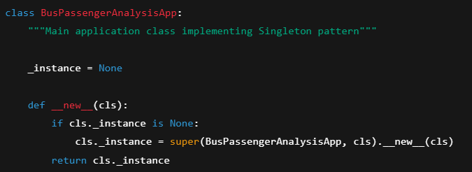
Figure 10: Coding example for singleton method design pattern

Code explanation: The BusPassengerAnalysisApp class implements the Singleton pattern to ensure only one instance of the application exists.

Impact: This prevents multiple dashboards from being initialized, ensuring data consistency and resource efficiency.

b) Factory method design pattern
The Factory Method pattern defines an interface for creating an object but lets subclasses decide which class to instantiate. It defers object instantiation to subclasses, making the code more flexible and scalable. This is particularly useful when a class can't anticipate the type of objects it needs to create (Gorai, 2024).

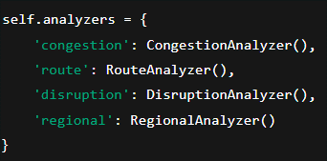
Figure 11: Coding example for factory method design pattern

Code explanation: The BusPassengerAnalysisApp acts like a factory for analyzers. Instead of creating them individually everywhere, it manages them in a single dictionary.

Impact: This makes the system extensible. If a new analyzer (e.g., RevenueAnalyzer) is added, it can be included in the dictionary without changing the rest of the application.

1.2.2 Structural Design Patterns
Structural design patterns are about how classes and objects are composed to form larger structures. They focus on simplifying the structure of a system by identifying a simple way to realize relationships between entities. These patterns help to reduce complexity by organizing objects and classes into larger, more cohesive structures. They often use concepts like inheritance and composition to build new functionalities (GeeksforGeeks, 2023).

a) Proxy method Design pattern
The Proxy design pattern provides a surrogate or placeholder for another object to control access to it. It acts as an intermediary, forwarding requests to the real object. This pattern is useful for adding a layer of control, such as access management, lazy initialization, or logging, without altering the real object's code (GeeksforGeeks, 2017).

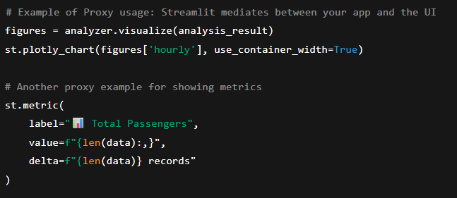
Figure 12: Coding example for Adapter method Design pattern

Code Explanation: The application uses Streamlit functions like st.plotly_chart, st.metric, and st.dataframe. These act as Proxies because they sit between your analyzer logic and the actual rendering engine. This code doesn’t directly manage rendering; it delegates it through Streamlit, which controls how the chart or data is shown to users.

Impact
- Decouples application logic from the GUI rendering engine.
- Allows analyzers to remain independent of the front-end framework.
- If the framework changes (e.g., switch from Streamlit to Flask+Dash), analyzers remain untouched.

b) Facade method design pattern
The Facade pattern provides a simplified interface to a complex system of classes, libraries, or frameworks. It hides the complexity of the subsystem from the client by providing a single, unified entry point. This makes the system easier to use and reduces dependencies (GeeksforGeeks, 2017).

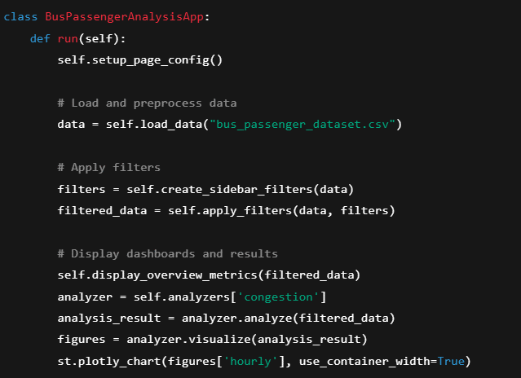
Figure 13: Coding example for Façade method design pattern

Code Explanation: The BusPassengerAnalysisApp class acts as a Facade because it provides a single-entry point (run()) that hides the complexity of multiple subsystems
- Data loading (DataProcessor)
- Filtering (SearchEngine + filters)
- Analysis (CongestionAnalyzer, RouteAnalyzer, etc.)
- Visualization (Plotly + Streamlit)
Users don’t need to know the details of how these work internally—they just interact with the app.

Impact
- Simplifies the user’s interaction with the system.
- Reduces coupling between the UI and internal subsystems.
- Makes the system easier to maintain and extend, since changes inside analyzers or filters don’t affect the interface.

1.2.3 Behavioural Design Patterns
Behavioural design patterns are concerned with how objects interact and distribute responsibility. They describe communication patterns between objects, making the system more flexible and reusable. These patterns focus on the algorithms and the assignment of responsibilities between objects. They help in designing objects that are not only responsible for their own state but also for their interactions with other objects.

a) Strategy method design pattern
The Strategy pattern defines a family of algorithms, encapsulates each one, and makes them interchangeable. It lets the algorithm vary independently from the clients that use it. This allows for a flexible design where a client can choose a behaviour at runtime (Shah, 2024).

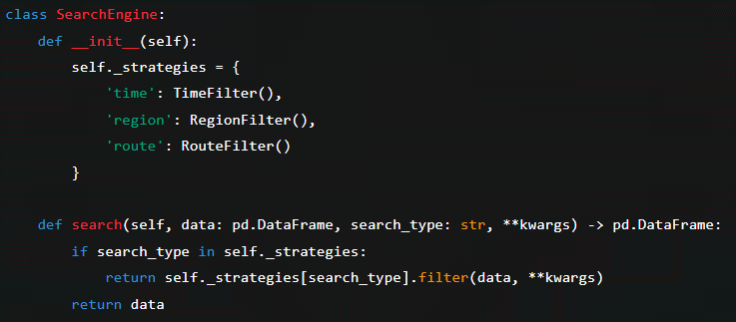
Figure 14: Coding example for Strategy method design pattern

Code Explanation: The SearchEngine implements the Strategy pattern. Different filtering algorithms are encapsulated as separate classes (TimeFilter, RegionFilter, RouteFilter), and SearchEngine chooses which one to apply based on user input.

Impact
- Makes filtering logic interchangeable without modifying the main app.
- New filtering strategies (e.g., FareFilter, StationFilter) can be added easily.
- Improves flexibility and adheres to the Open/Closed Principle (extend without modifying existing code).

b) Template method design pattern
The Template Method pattern defines the skeleton of an algorithm in a base class but lets subclasses override specific steps of the algorithm without changing its overall structure. It's a way to reuse code and ensure that the structure of an operation remains consistent across different implementations (GeeksforGeeks, 2017).

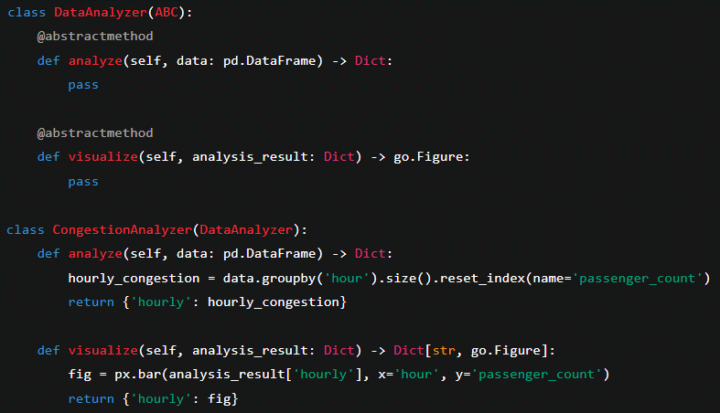
Figure 15: Coding example for Template method design pattern

Code Explanation: The DataAnalyzer abstract base class demonstrates the Template Method pattern. It defines the structure for analyzers with the methods analyze and visualize. Subclasses (CongestionAnalyzer, RouteAnalyzer, DisruptionAnalyzer, RegionalAnalyzer) provide their own implementations for these steps, but the overall workflow remains consistent.

Impact
- Ensures all analyzers follow the same blueprint.
- Makes the system extensible: new analyzers can be created by implementing the same template.
- Promotes code reusability and consistency across multiple modules.

1.3 The impact of clean coding techniques on the use of data structures and operations when writing algorithms
Clean coding is a set of principles and practices that make software code readable, maintainable, and efficient. It emphasizes writing code in a way that is easy to understand for both the original author and future developers who may maintain the system. In large-scale applications such as the Bus Passenger Data Analysis Application, clean coding becomes critical since the software handles big data processing, analysis, and visualization.

One of the most important areas impacted by clean coding techniques is the use of data structures and algorithms. Choosing the right data structures and applying clean coding practices directly influences the performance, scalability, and maintainability of algorithms.

1. Meaningful Naming
Using descriptive and meaningful names for variables, methods, and classes improves readability and ensures clarity in data structure usage (Codacy, 2023).
- Impact on Data Structures: Instead of generic names like arr or x, meaningful names like passenger_data, filtered_routes, or hourly_congestion make it clear what data is being stored and processed.
- Impact on Algorithms: Helps developers understand algorithm logic quickly without deep diving into the implementation. For example, an aggregation algorithm over route_popularity is more intuitive than over a vague df1.

Before (bad code – unclear names):
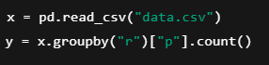
Figure 16: Before using Meaningful Naming technique
After (clean code – meaningful names):
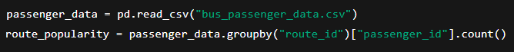
Figure 17: after using Meaningful naming technique

2. Single Responsibility Principle (SRP)
Each class or method should focus on a single responsibility (zen8labs, 2024).
- Impact on Data Structures: Data operations are clearly separated. For instance, DataProcessor handles preprocessing while analyzers handle analysis, ensuring no overlap.
- Impact on Algorithms: Algorithms remain focused and optimized. A method responsible for filtering will not mix in visualization logic, making data traversal more efficient and debugging easier.

Before (bad code – mixing responsibilities):
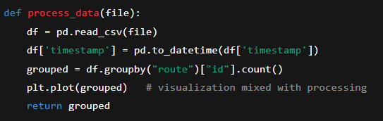
Figure 18: Before using Single Responsibility Principle (SRP)

After (clean code – separate responsibilities):
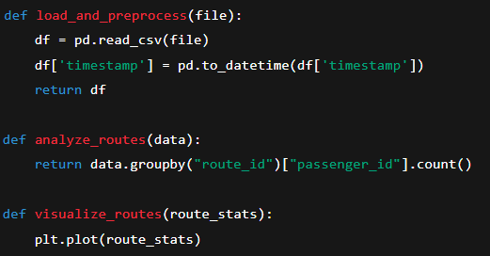
Figure 19: after using Single Responsibility Principle (SRP)

3. Consistent Formatting and Code Structure
Consistent indentation, spacing, and structure (like proper method grouping) makes algorithms easier to follow (Codacy, 2023).
- Impact on Data Structures: Developers can quickly spot how lists, dictionaries, or DataFrames are created, modified, or returned.
- Impact on Algorithms: Complex operations such as filtering or aggregating large datasets become easier to trace, minimizing logical errors and improving debugging.

Before (bad code – messy formatting):
Figure 20: before using Consistent Formatting and Code Structure

After (clean code – consistent style):
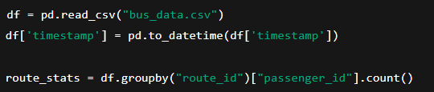
Figure 21: after using Consistent Formatting and Code Structure

4. Modularity and Reusability
Breaking large tasks into smaller reusable functions and classes improves maintainability.
- Impact on Data Structures: Data structures like DataFrame are passed between functions instead of being duplicated, reducing memory usage in large datasets.
- Impact on Algorithms: Algorithms like grouping, filtering, or aggregating are implemented once and reused across analyzers, reducing redundancy and improving reliability.

Before (bad code – duplicated logic):
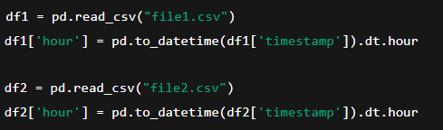
Figure 22: before using Modularity and Reusability
After (clean code – reusable function):
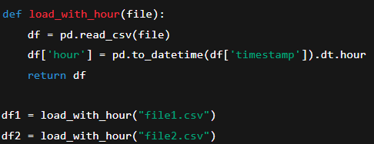
Figure 23: after using Modularity and Reusability

5. Error Handling and Robustness
Clean code handles exceptions gracefully without breaking execution (zen8labs, 2024).
- Impact on Data Structures: Ensures corrupt or incomplete data structures (like missing values in a dataset) are handled safely. For instance, filling missing values in transfer stations avoids algorithm failures.
- Impact on Algorithms: Prevents runtime errors in iterative or recursive algorithms, especially when processing big datasets in chunks. This ensures system stability and reliable performance.

Before (bad code – no error handling):
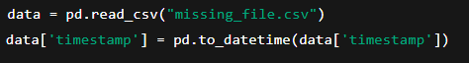
Figure 24: before using Error Handling and Robustness

After (clean code – robust error handling):
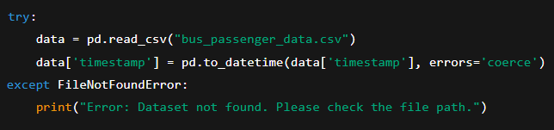
Figure 25: after using Error Handling and Robustness

6. Avoiding Code Duplication
Algorithms and data operations should not be repeated unnecessarily (Codacy, 2023).
- Impact on Data Structures: Shared operations like converting timestamps or extracting features (hour, day, month) are centralized in DataProcessor, so they aren’t redundantly applied in every analyzer.
- Impact on Algorithms: Reduces algorithmic complexity and improves performance by avoiding repeated operations on large datasets.

Before (bad code – repeated feature extraction):
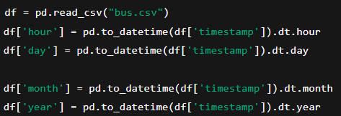
Figure 26: before using Avoiding Code Duplication

After (clean code – centralized in one function):
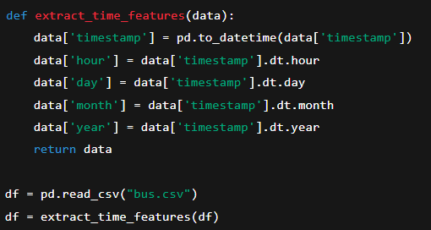
Figure 27: after using Avoiding Code Duplication

7. Readability and Documentation
Adding comments and docstrings improves code comprehension for future developers (zen8labs, 2024).
- Impact on Data Structures: Describes why certain data structures (like dictionaries for analyzers, DataFrames for passenger data) are used, justifying their efficiency.
- Impact on Algorithms: Provides clarity in algorithm steps (e.g., how anomalies are detected or congestion is calculated), making it easier to optimize or extend in the future.

Before (bad code – no comments, hard to follow):
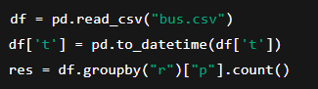
Figure 28: before using Readability and Documentation

After (clean code – with comments and docstrings):
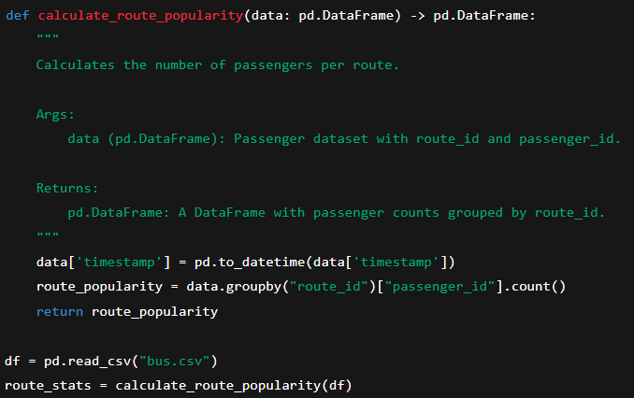
Figure 29: after using Readability and Documentation

Clean coding techniques are not just about style; they directly affect how effectively data structures and algorithms are implemented. In the Bus Passenger Data Analysis Application, these techniques ensure that the system can handle large-scale passenger datasets efficiently while remaining modular, maintainable, and extensible. As the dataset grows or new analytical requirements arise, the impact of clean coding becomes even more significant for long-term success.

1.4 Evaluation on the Impact of SOLID Principles in Object-Oriented Application Development
The SOLID principles - an acronym coined by Robert C. Martin - represent five foundational tenets of object-oriented design aimed at improving maintainability, extensibility, testability, and scalability of software systems Here’s a structured breakdown of each principle:

1.4.1. Single Responsibility Principle (SRP)
Each class or module should have one, and only one, reason to change, meaning it should focus on a single responsibility Violating SRP often leads to monolithic “God classes” that bundle unrelated functionality (Ramos, 2023).

Impact:
- Enhances maintainability—small, focused classes are easier to understand and modify.
- Improves testability—isolating behavior makes unit testing simpler.
- Reduces coupling, since changing one aspect doesn’t ripple through the rest of the system.

Coding Example:
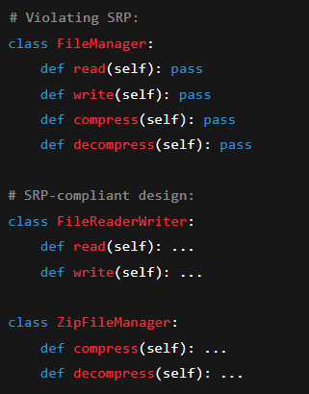
Figure 30: Coding example for Single Responsibility Principle (SRP)
Here, responsibilities are cleanly separated into smaller, more focused classes

1.4.2. Open–Closed Principle (OCP)
Software entities (classes, modules, functions, etc.) should be open for extension but closed for modification, you should add behaviour without altering existing code (Ramos, 2023).

Impact:
- Promotes extensibility and reduces the risk of regressions.
- Encourages safe scaling—new features can be added with minimal disruption to stable code.

Coding Example:
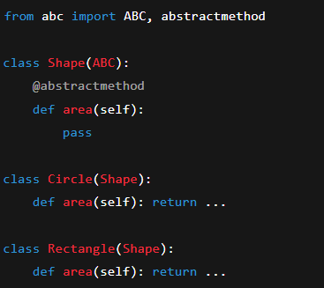
Figure 31: Coding example for Open–Closed Principle (OCP)

To add a new shape, you extend the base Shape class without modifying existing implementations—a clear application of the OCP

1.4.3. Liskov Substitution Principle (LSP)
Subtypes must be substitutable for their base types without altering the correctness of the program. Essentially, the behaviour of derived classes should align with expectations established by the parent class (Özateş, 2022).

Impact:
- Enhances polymorphism and ensures reliable substitution.
- Preserves program correctness—no unexpected behavior when replacing parent with child.

Coding Example:

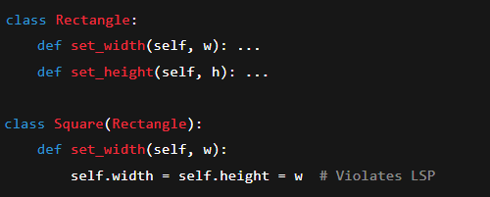
Figure 32: Coding example for Liskov Substitution Principle (LSP)

A Square breaks LSP by changing behaviour of set_width; replacing a Rectangle reference with a Square leads to unexpected behaviour.

1.4.4. Interface Segregation Principle (ISP)
Clients should not be forced to depend on methods they do not use. Favor smaller, specific interfaces rather than monolithic ones (umaparvathy, 2023).

Impact:
- Promotes decoupling—clients only rely on what's necessary.
- Encourages flexibility and clarity, reducing overhead for implementers.

Coding Example:

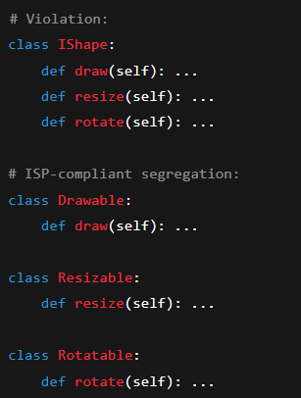
Figure 33: Coding example for Interface Segregation Principle (ISP)

Clients only implement needed capabilities, keeping dependencies minimal.

1.4.5. Dependency Inversion Principle (DIP)
High-level modules should not depend on low-level modules but on abstractions. Additionally, abstractions should not depend on details—details should depend on abstractions (umaparvathy, 2023).

Impact:
- Decreases coupling, making components easier to replace or extend.
- Enhances testability through dependency injection of mock implementations.
- Improves flexibility—you can easily swap implementations without touching high-level logic.

Coding Example:
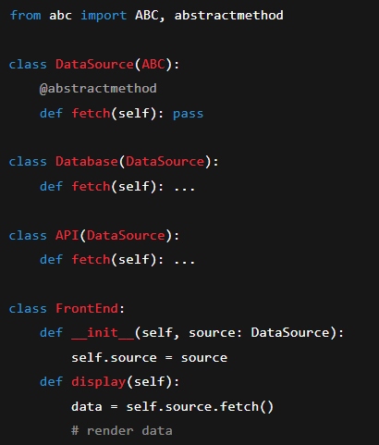
Figure 34: Coding example for Dependency Inversion Principle (DIP)
Here, FrontEnd depends on the abstraction DataSource, not concrete implementations—facilitating extension and testing.

Part 2
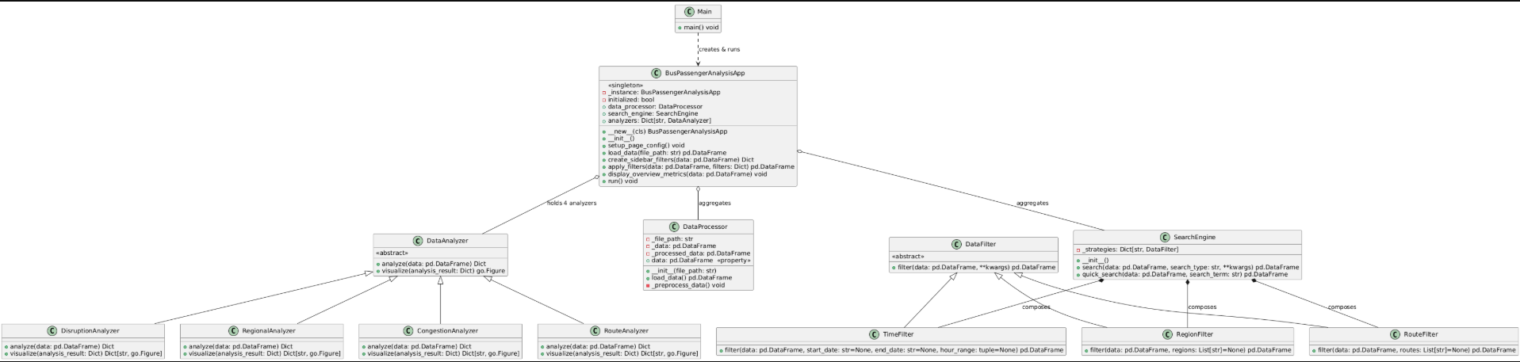
Figure 35: UML class diagram before refinements

The initial UML class diagram provides a structural view of the system without emphasizing specific design patterns. It identifies the core components such as DataProcessor (responsible for loading and preprocessing data), SearchEngine (responsible for filtering and searching), and a set of specialized DataAnalyzer subclasses (for congestion, route, disruption, and regional analysis). The diagram also highlights the main relationships among components: aggregation of analyzers within the main application class, and the use of multiple filter classes by the search engine. This version serves as a straightforward documentation of the system’s classes, attributes, and interactions but does not explicitly capture higher-level design principles.

2.1 Utilization of SOLID Principles, Clean Coding Techniques, and Design Patterns in the Proposed Application

2.1.1 Utilization of SOLID Principles
The proposed bus passenger analysis system has been designed with adherence to the SOLID principles, ensuring scalability, flexibility, and maintainability.

- Single Responsibility Principle (SRP):
Each class in the system has a well-defined responsibility. For example, the DataProcessor class is solely responsible for data loading and preprocessing, while SearchEngine handles filtering and search logic. Similarly, each DataAnalyzer subclass (e.g., CongestionAnalyzer, RouteAnalyzer) is responsible for analyzing a specific aspect of the data.

- Open/Closed Principle (OCP):
The design allows extension without modifying existing classes. For instance, new analyzer types can be introduced by simply creating new subclasses of DataAnalyzer. Likewise, additional filters can be added by extending the DataFilter abstraction without altering the SearchEngine logic.

- Liskov Substitution Principle (LSP):
All subclasses of DataAnalyzer and DataFilter can be substituted wherever their parent class is expected. This ensures consistent behavior and interchangeable use of analyzers and filters.

- Interface Segregation Principle (ISP):
Abstract classes such as DataAnalyzer and DataFilter expose only the methods necessary for their specific functionality. This prevents subclasses from being forced to implement methods that are irrelevant to them.

- Dependency Inversion Principle (DIP):
High-level modules such as BusPassengerAnalysisApp depend on abstractions (DataAnalyzer, DataFilter) rather than concrete implementations. This makes the system flexible and reduces tight coupling between components.

2.1.2 Utilization of Clean Coding Techniques
The application also applies clean coding techniques to ensure readability, maintainability, and ease of collaboration.

- Meaningful Naming Conventions:
Class names such as DataProcessor, SearchEngine, and RouteAnalyzer clearly describe their responsibilities. Variable and method names are self-explanatory, minimizing ambiguity.

- Code Modularization:
The system is divided into smaller, reusable modules. Each class and method serves a single, focused purpose, reducing complexity and increasing readability.

- Encapsulation and Information Hiding:
Private attributes (e.g., _data, _file_path) restrict direct access, and public methods provide controlled interaction with class internals. This protects data integrity and enforces clear boundaries.

- Consistency and Style:
The code follows a consistent style in terms of formatting, naming, and method structuring. This ensures uniformity across the system and makes the application easier to extend or debug.

- Error Handling and Robustness:
Methods like load_data() and filtering functions are designed to handle invalid inputs gracefully, increasing system reliability.

3.1.3 Utilization of Design Patterns
The proposed system incorporates several design patterns to improve flexibility and maintainability.
- Singleton Pattern:
The BusPassengerAnalysisApp class is implemented as a <<Singleton>>, ensuring that only one instance of the main application exists throughout execution. This centralizes system control and resource management.

- Strategy Pattern:
The SearchEngine class uses the <<Strategy>> pattern by delegating search operations to interchangeable filter strategies such as TimeFilter, RegionFilter, and RouteFilter. This provides flexibility to add or replace filtering strategies without modifying core logic.

- Template Method Pattern:
The DataAnalyzer abstract class follows the <<Template Method>> pattern, defining the structure of analysis and visualization while allowing subclasses (e.g., CongestionAnalyzer, RouteAnalyzer) to implement specific behaviors. This promotes consistency across analyzers while supporting specialization.

- Facade Pattern:
The BusPassengerAnalysisApp also acts as a <<Facade>> by providing a simplified interface (run(), apply_filters(), display_overview_metrics()) to interact with complex subsystems such as the DataProcessor, SearchEngine, and various analyzers. This hides implementation details and makes the application easier to use and maintain.

- Factory Method Pattern:
Analyzer instantiation within BusPassengerAnalysisApp reflects the use of the <<Factory Method>> pattern. By maintaining analyzers in a dictionary and initializing them dynamically, the system supports seamless addition of new analyzers without modifying client code.

- Extensibility for Future Patterns:
The modular design also supports the introduction of additional patterns in future development. For example, a Factory Method could be introduced for dynamic analyzer creation, or an Observer pattern could be applied to update the UI automatically when new data is analyzed.

By carefully applying SOLID principles, clean coding techniques, and established design patterns, the proposed application achieves high modularity, maintainability, and extensibility. The system design not only addresses current functional requirements but also establishes a strong foundation for future enhancements and scalability.

2.2 Explanation about how the design of the proposed application is refined to include multiple design patterns.

The initial design of the proposed bus passenger analysis application was centered on the basic class structure, highlighting the main components such as the DataProcessor, SearchEngine, and various DataAnalyzer subclasses. While this unrefined design documented the relationships and responsibilities of classes, it did not explicitly capture the underlying design principles that could improve flexibility, scalability, and maintainability.

To refine the system design, multiple design patterns were incorporated and clearly mapped to different parts of the application. This refinement ensures that the architecture not only represents structural relationships but also demonstrates intentional use of reusable and well-established solutions to common software problems.

- Singleton Pattern:
The BusPassengerAnalysisApp was refined into a <<Singleton>>, ensuring centralized control by restricting instantiation to a single object. This refinement prevents conflicts that could arise from multiple application instances.
- Strategy Pattern:
The search functionality was enhanced using the <<Strategy>> pattern, where the SearchEngine can dynamically choose between different filtering strategies (TimeFilter, RegionFilter, RouteFilter). This refinement decouples the filtering logic from the search engine and makes the system easier to extend with new search strategies.
- Template Method Pattern:
The design of analyzers was refined using the <<Template Method>> pattern. The DataAnalyzer abstract class now defines the standard framework for analysis and visualization, while its subclasses override specific steps. This refinement enforces consistency while allowing specialized behaviors.
- Factory Method Pattern:
The instantiation of analyzers within the main application was further refined to use a <<Factory Method>> approach. By maintaining analyzers in a dictionary and constructing them dynamically, the system supports easy extension with new analyzers without modifying client code.
- Facade Pattern:
Finally, the role of the BusPassengerAnalysisApp itself was refined into a <<Facade>>, exposing simple methods such as run(), apply_filters(), and display_overview_metrics() while hiding the complexity of the underlying subsystems. This refinement makes the application easier to use and enhances maintainability.

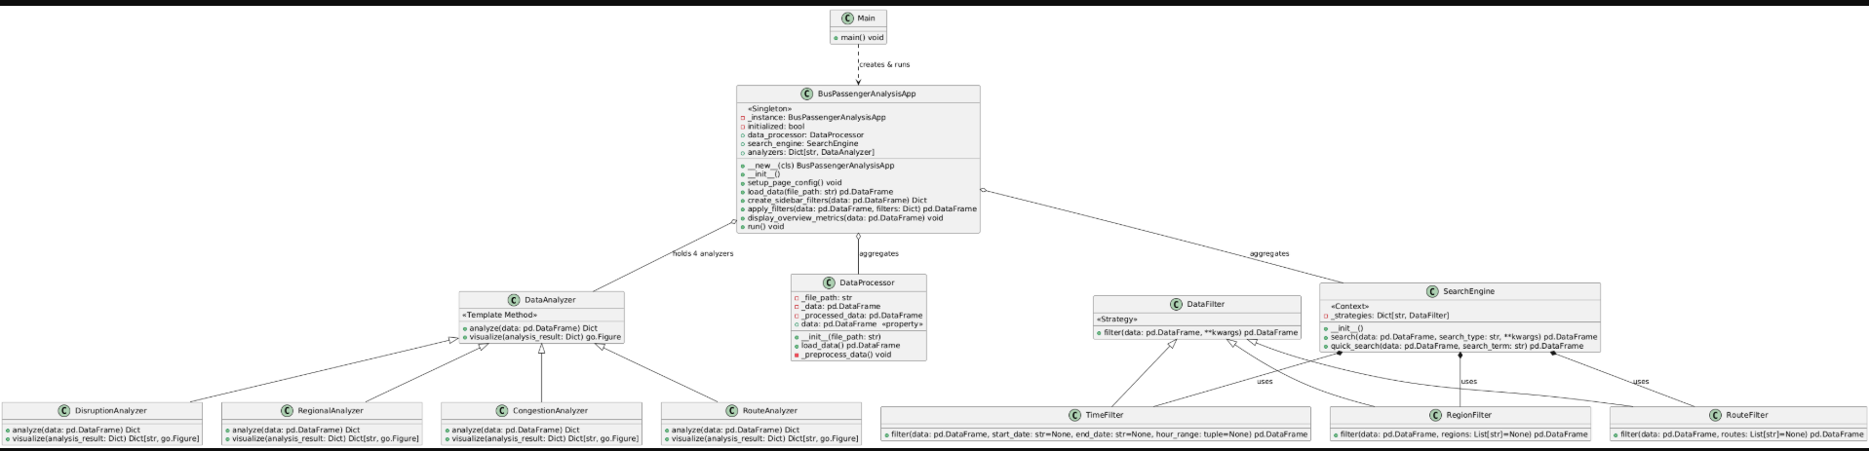
Figure 36: UML class diagram after the refinements

The refined UML class diagram improves upon the initial structure by explicitly highlighting the design patterns that shape the system. The BusPassengerAnalysisApp class is shown as a <<Singleton>>, ensuring that only one instance of the application exists throughout execution. The SearchEngine class implements the <<Strategy>> pattern, delegating filtering logic to interchangeable filter classes such as TimeFilter, RegionFilter, and RouteFilter.

The DataAnalyzer hierarchy adopts the <<Template Method>> pattern, where the abstract class defines a framework for analysis and visualization, while concrete subclasses implement specific behaviours. By pointing out these patterns, the refined diagram emphasizes not just the structure but also the intentional design choices that make the system more flexible, extensible, and maintainable.

Through these refinements, the application design evolved from a basic representation of classes into a pattern-oriented architecture that is robust, modular, and future-proof. By combining multiple design patterns, the proposed system is better positioned to handle complexity, support extension, and provide a clean separation of concerns.

2.3 Designing a test plan (testing regime) for the proposed application by including a provision for automated testing.

2.3.1 Testing Strategies
The proposed application adopts a hybrid testing strategy that combines manual testing and automated testing to ensure correctness, reliability, and maintainability.
- Unit Testing: Each component (e.g., DataProcessor, SearchEngine, DataAnalyzer subclasses) is tested independently using automated frameworks such as pytest to verify correctness of individual methods.
- Integration Testing: Ensures that modules interact correctly, e.g., verifying that the BusPassengerAnalysisApp correctly integrates analyzers, filters, and data processor.
- Functional Testing: Validates whether the system features (e.g., congestion analysis, disruption detection) work as intended against user requirements.
- Regression Testing: Automated tests are re-executed whenever code changes to ensure new updates do not break existing features.
- Performance Testing (Optional): Evaluates application responsiveness when processing large datasets.

2.3.2 Test Plan for the Proposed Application
- Content
- Objectives
- Objects to be tested
- System features
- Schedule of the testing
- Tools used for the testing

- Objectives
- To verify that all components of the bus passenger analysis application work as expected.
- To ensure that the system features (congestion analysis, route analysis, disruption detection, regional analysis) produce accurate and reliable results.
- To validate integration of different modules (data loading, filtering, searching, analyzing, and visualization).
- To confirm maintainability by introducing automated testing using pytest, allowing repeatable and efficient test execution.

- Objects to be Tested
- Peak Congestion Analysis – correctness of passenger congestion detection.
- Popular Route and Transfer Point Analysis – accuracy in identifying most used routes and transfer points.
- Service Disruption Detection – ability to flag abnormal or missing services.
- Regional Performance Analysis – evaluation of service quality and reliability across regions.

- System Features

Hardware Requirements:
- RAM: 8 GB minimum (16 GB recommended).
- Hard Disk: 500 MB for application and dataset storage.
- Processor: Intel i5 / AMD Ryzen 5 (or higher).

Software Requirements:
- Operating System: Windows 10 / Linux Ubuntu 20.04 / macOS Ventura.
- Python IDE: PyCharm / VS Code / Jupyter Notebook.
- Python Packages and Libraries:
  - pandas, numpy (data handling & preprocessing)
  - plotly, matplotlib (visualization)
  - pytest, unittest (testing framework)
  - streamlit (application interface)

- Schedule of the Testing (Unit Tests using pytest)

Task | Start Date | End Date
Write unit tests for DataProcessor | 01-Aug-2025 | 03-Aug-2025
Write unit tests for DataFilter & SearchEngine | 04-Aug-2025 | 07-Aug-2025
Write unit tests for DataAnalyzer subclasses | 08-Aug-2025 | 12-Sep-2025
Integration testing of modules | 13-Aug-2025 | 15-Aug-2025
Functional testing of full application | 16-Aug-2025 | 18-Aug-2025
Regression testing (automated re-runs) | 19-Aug-2025 | 20-Aug-2025
Table 1: Testing Schedule

- Tools Used for the Testing
- Python Libraries:
  - pytest → Unit and integration testing
  - pandas & numpy → Test dataset creation and validation
  - coverage.py → Code coverage reporting

Part 3

3.1 Source Code of the Developed System with evidence.
In this part I attached my source code screenshots as evidence of the system development as proposed. The complete source code attached along with the report.

3.1.1 Core Abstractions

a) DataAnalyzer (analysis contract)
Defines the analysis interface used across all analyzers. This abstraction enables consistent pipelines and easy extension with new analyzers.
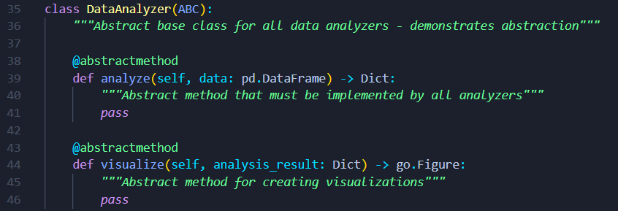
Figure 37: DataAnalyzer class

b) DataFilter (filtering contract) + concrete strategies
A strategy interface (DataFilter) plus three concrete strategies (time/region/route). The SearchEngine can swap these without changing its own code.
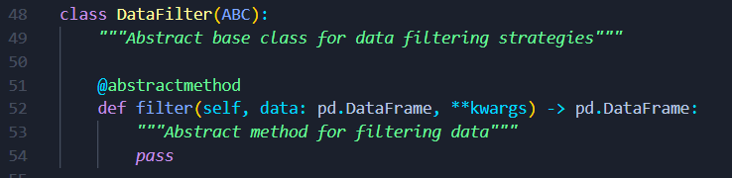
Figure 38: DataFilter class

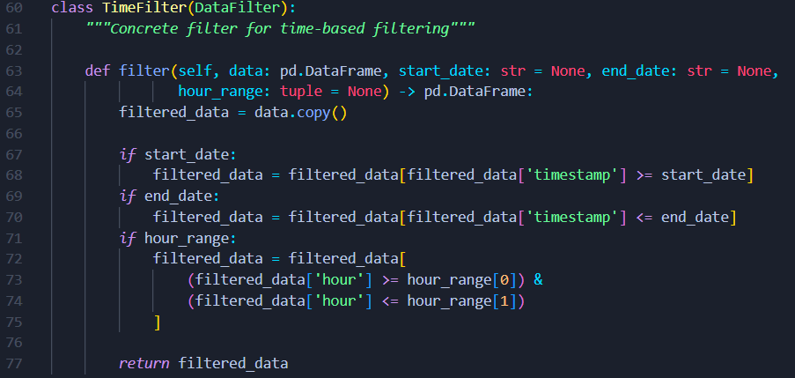
Figure 39: TimeFilter Class

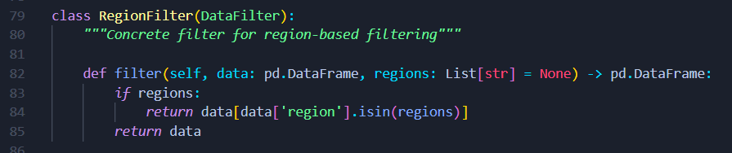
Figure 40: RegionFilter class

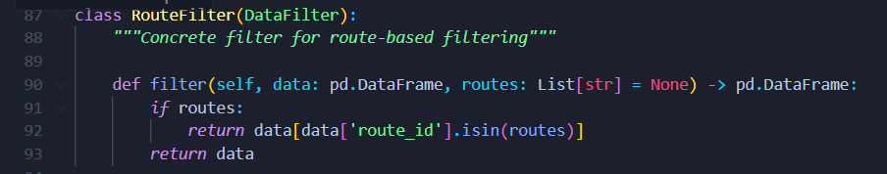
Figure 41: RouteFilter class

3.1.2 Data Access & Preprocessing

a) DataProcessor (repository for datasets)
Encapsulates file I/O and preprocessing (parsing dates/hours). Exposes a clean data property used by analyzers and search.

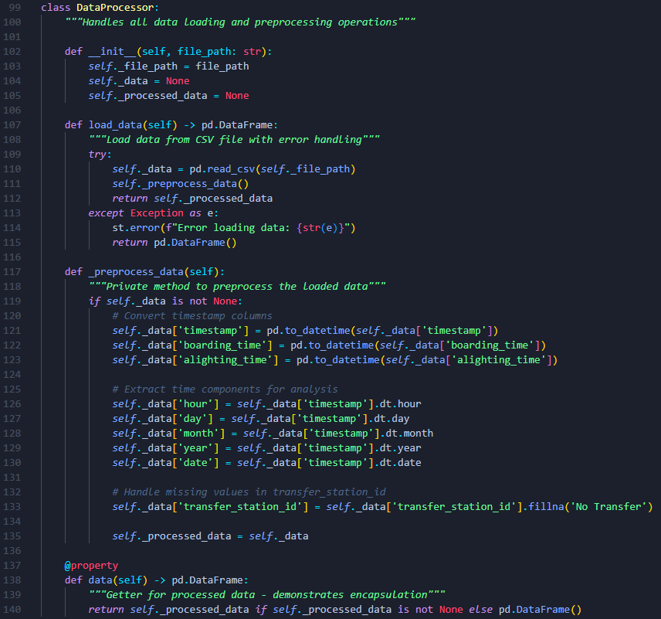
Figure 42: DataProcessor class

3.1.3 Search & Filtering Orchestration

a) SearchEngine (context that applies strategies)
Holds a registry of filter strategies and applies them via search(). quick_search() provides fuzzy term-based filtering.

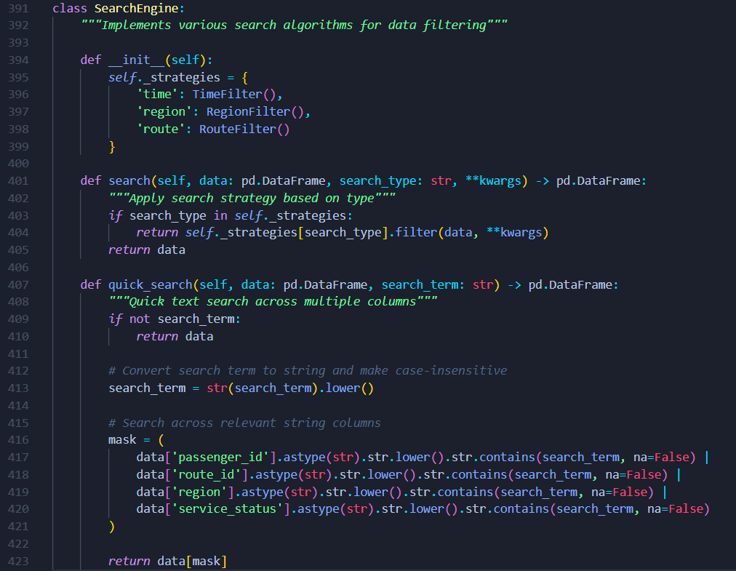
Figure 43: SearchEngine class

3.1.4 Analytical Modules

a) CongestionAnalyzer
Aggregates passenger counts by hour and identifies top peak hours. Returns Plotly figures for dashboard use.

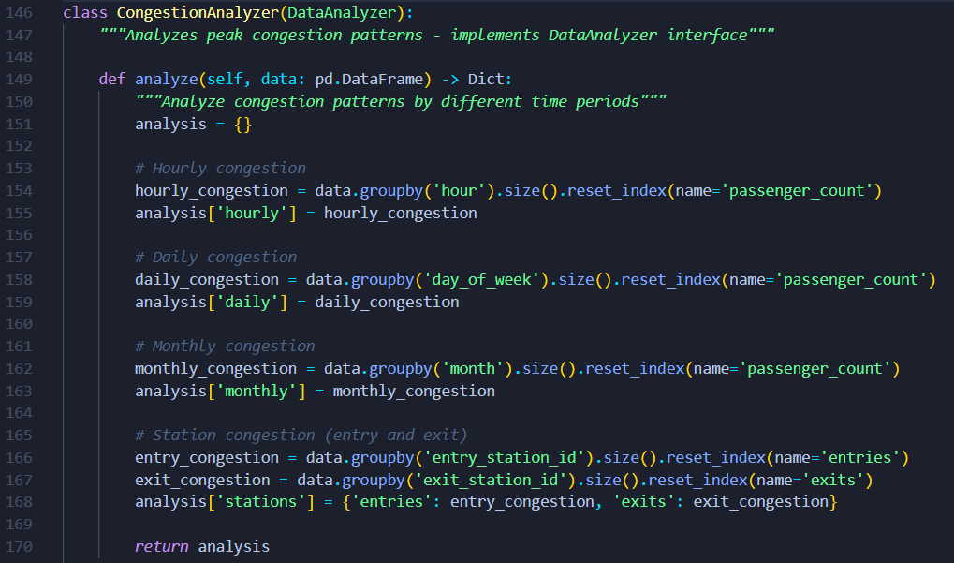
Figure 44: CongestionAnalyzer class 1

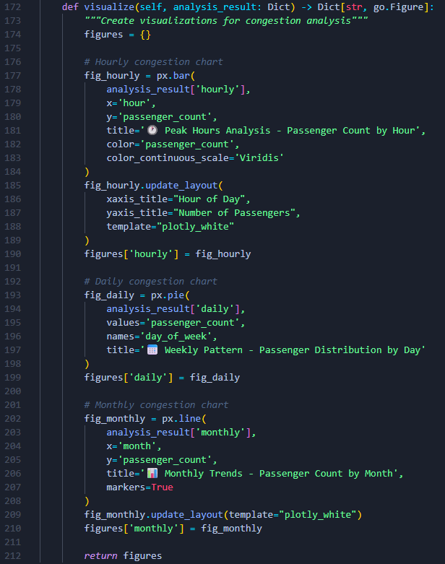
Figure 45: CongestionAnalyzer class 2

b) RouteAnalyzer
Finds popular routes and transfer hubs; provides visuals for each.

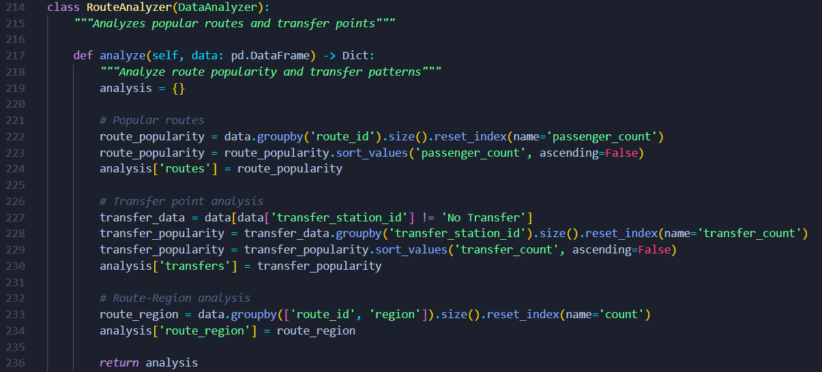
Figure 46: RouteAnalyzer class 1

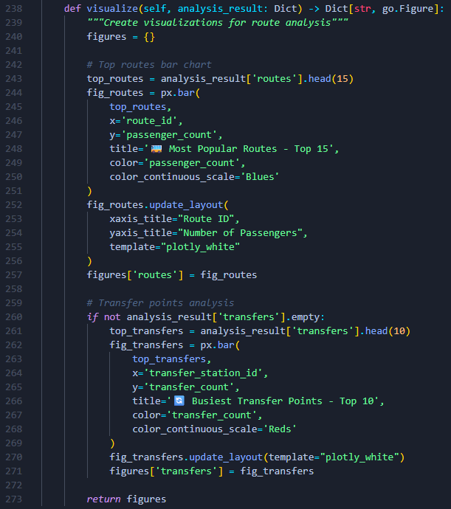
Figure 47: RouteAnalyzer class 2

c) DisruptionAnalyzer
Flags potential service disruptions by detecting zero-passenger gaps and renders a route–hour heatmap.

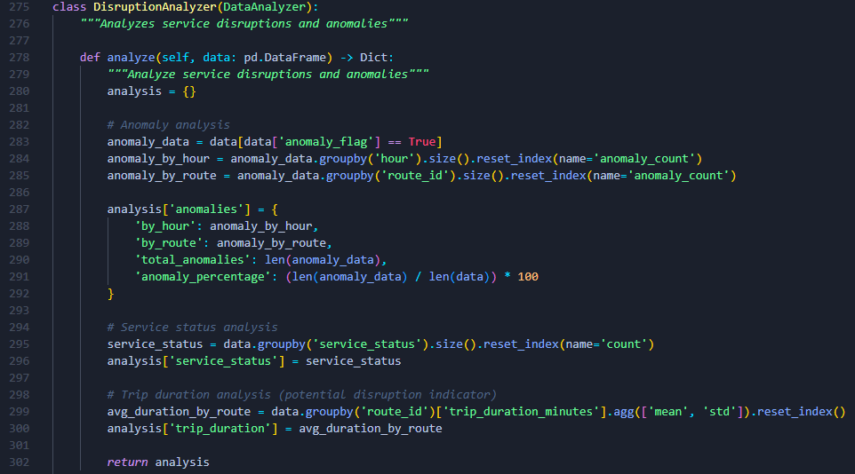
Figure 48: DisruptionAnalyzer class 1

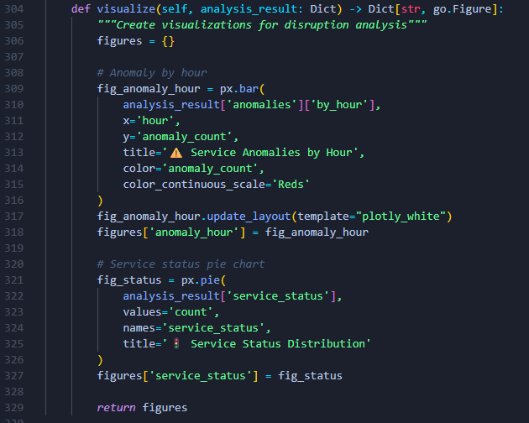
Figure 49: DisruptionAnalyzer class 2

d) RegionalAnalyzer
Compares demand and reliability across regions to spot under/over-performing areas.

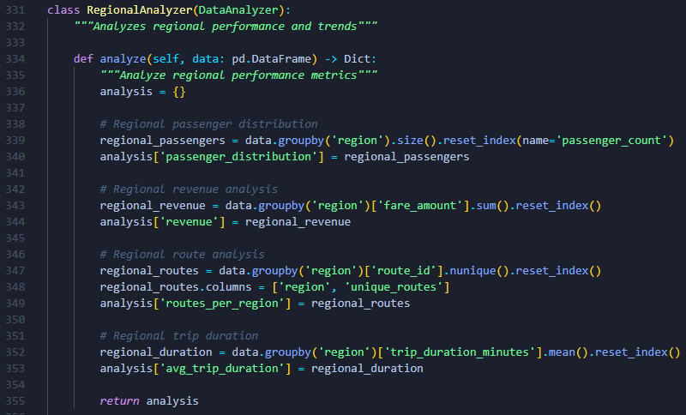
Figure 50: RegionalAnalyzer class 1

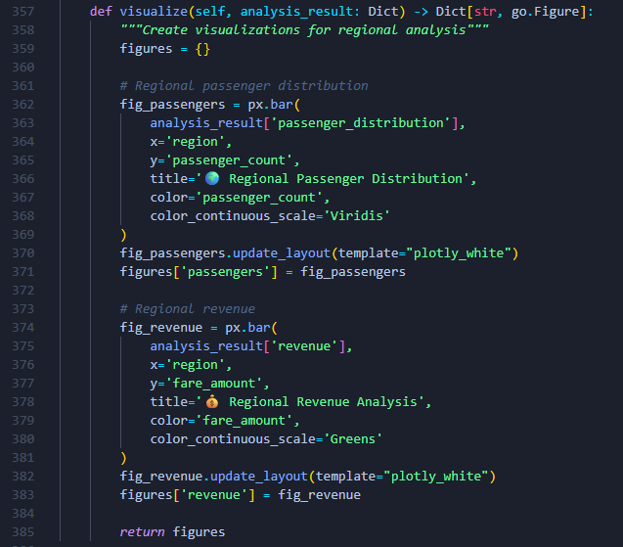
Figure 51: RegionalAnalyzer class 2

3.1.5 Application Orchestration

a) BusPassengerAnalysisApp — creation & config
Enforces a single app instance (__new__), wires dependencies, and configures the Streamlit page.

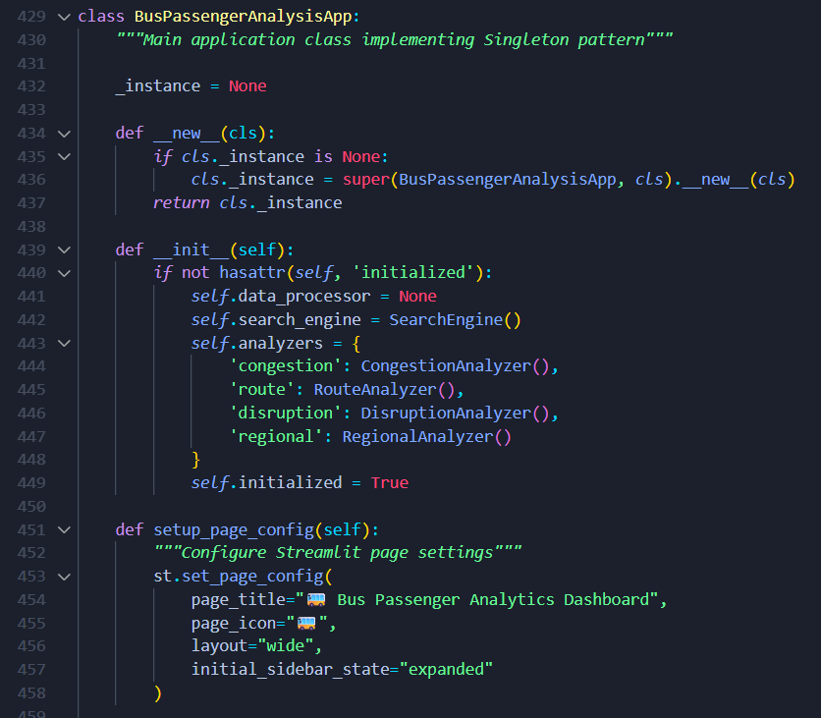
Figure 52: BusPassengerAnalysisApp

b) load_data, create_sidebar_filters, apply_filters
Loads data, constructs a consistent filter UI, then pipelines multiple strategies (time → region → route → quick) in apply_filters.

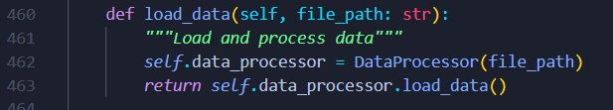
Figure 53: load_data function

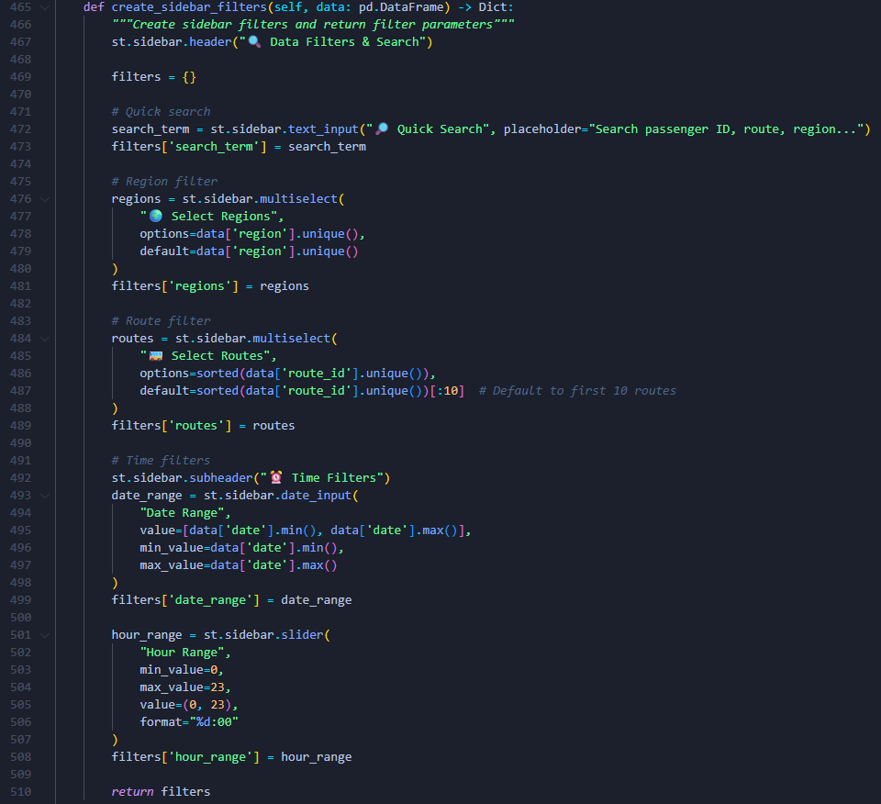
Figure 54: create_sidebar_filters function

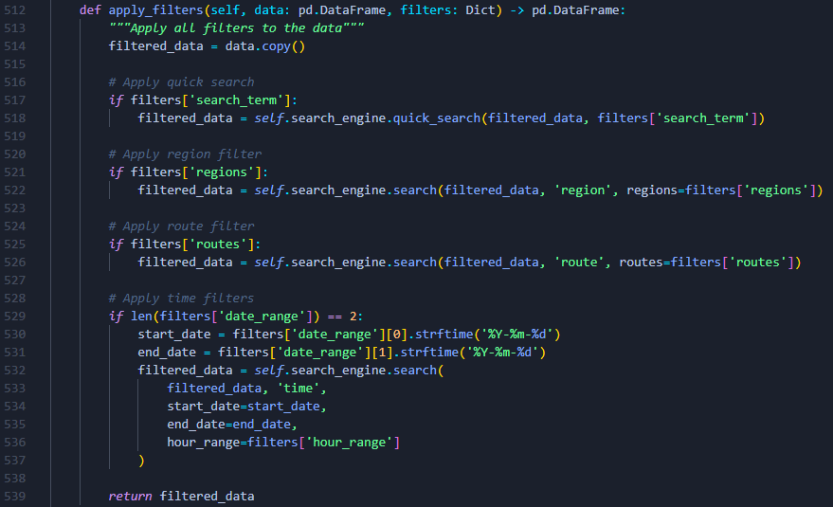
Figure 55: apply_filters function

c) Overview metrics + run() (UI composition)
Composes the Streamlit UI: upload → load → filter → metrics → tabbed analyses, delegating analytics to pluggable analyzers.

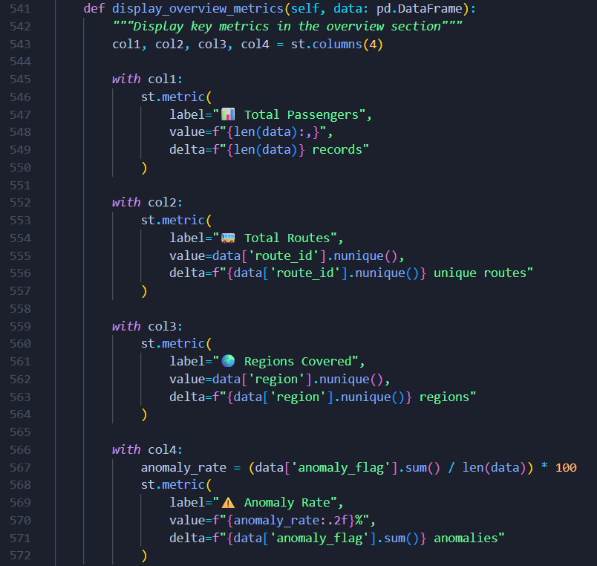
Figure 56: display_overview_metrics function
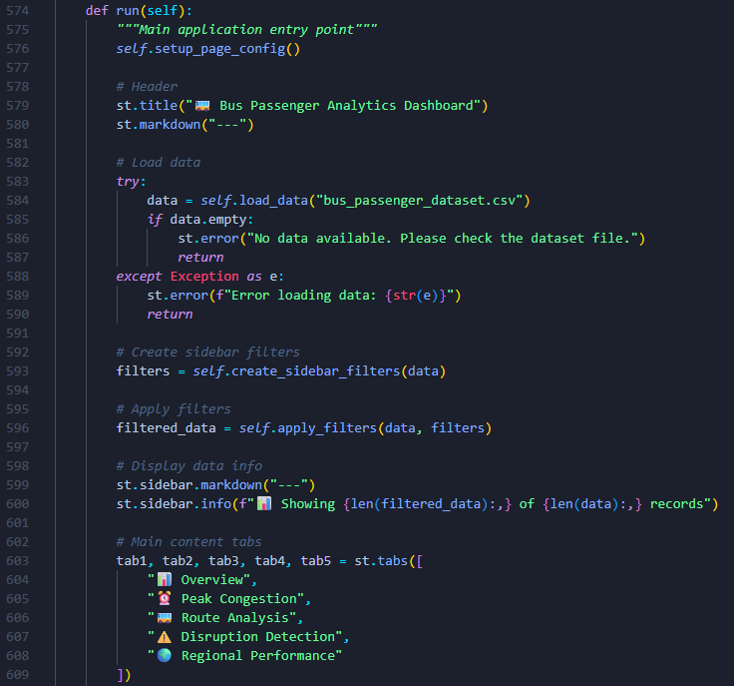
Figure 57: run function

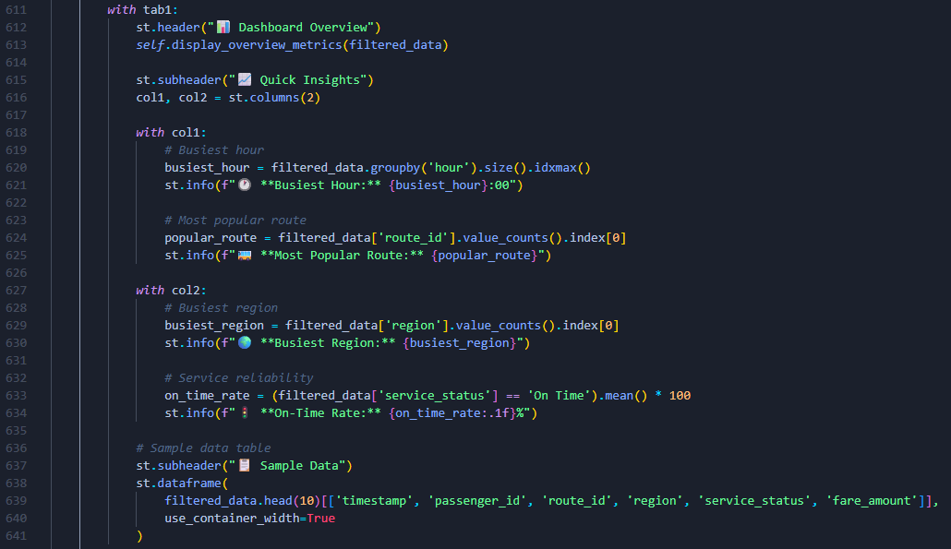
Figure 58: run function tab 1

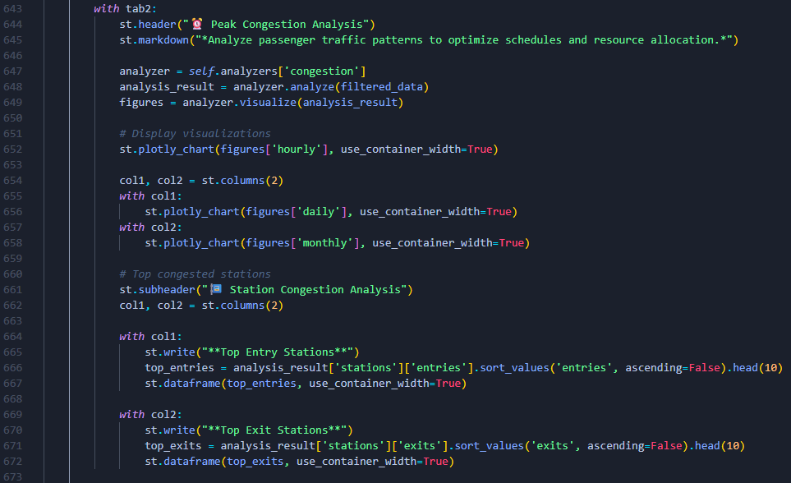
Figure 59: run function tab 2

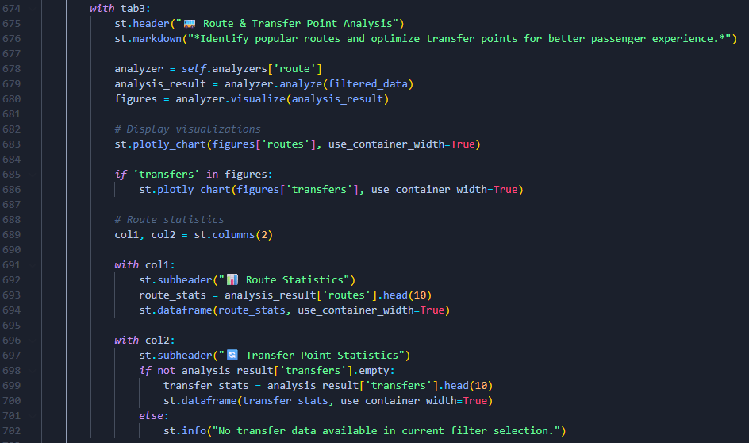
Figure 60: run function tab 3

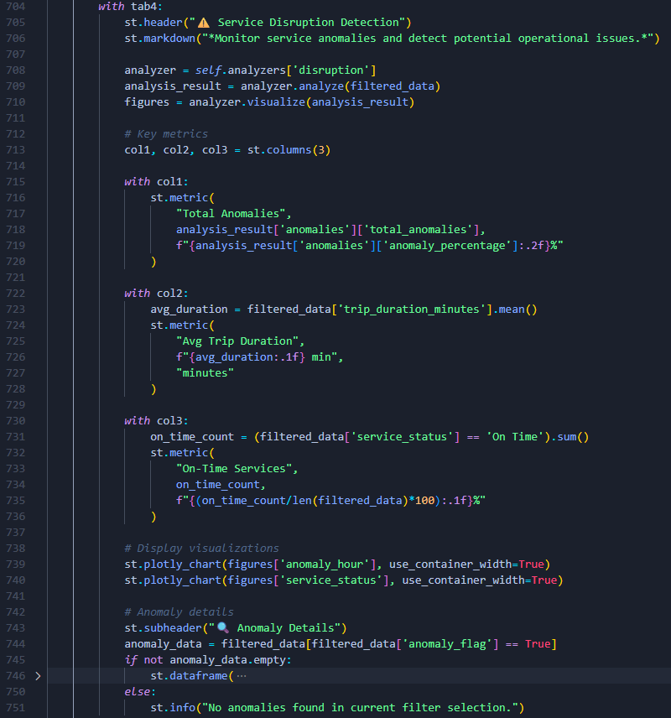
Figure 61: run function tab 4

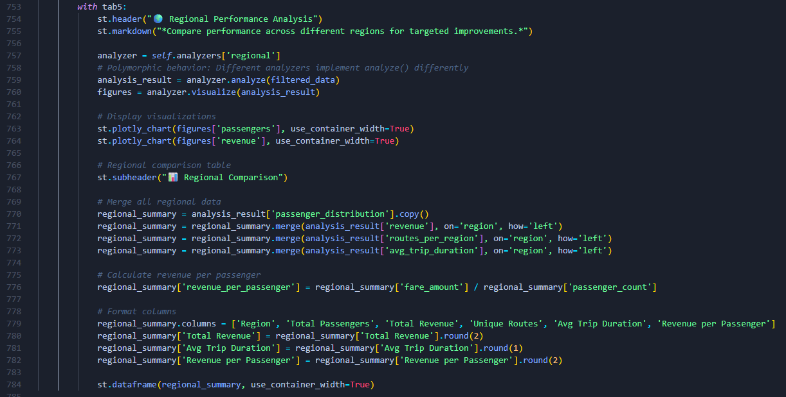
Figure 62: run function tab 5

1.3.6 Entry Point
Starts the app with a single instance and runs the Streamlit workflow.

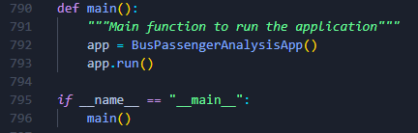
Figure 63: main function

3.2 Interface overview of the Developed System with evidence.

3.2.1 Sidebar Filters
- Description:
A filter panel located in the sidebar where users can define the scope of analysis.
- UI Elements:
  - Date range picker (start date and end date).
  - Multi-select dropdown for Regions.
  - Multi-select dropdown for Routes.
  - Slider for Hour range (e.g., 6 AM – 10 AM).
  - Quick search bar for free-text search (route or region).
- Purpose:
Provides flexible filtering strategies, allowing the user to refine the dataset interactively before analysis.
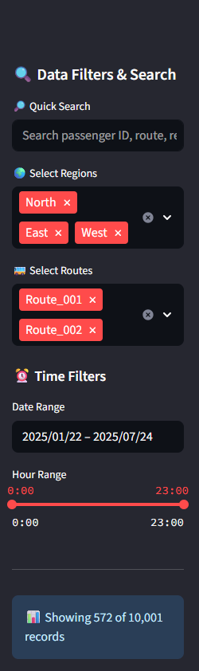
Figure 64: sidebar (interface)

3.2.2 Overview Metrics Section
- Description:
A dashboard-style display at the top of the main panel summarizing key dataset statistics.
- UI Elements:
  - Total Passengers (numeric value with formatting).
  - Total Routes (count of unique routes).
  - Total Regions (count of unique regions).
  - Anomaly Rate (percentage of the anomalies)
  - Quick insights (Busiest Hour, Busiest Region, Popular Route, On-Time Rate)
- Purpose:
Gives the user a quick overview of the dataset after filters are applied.
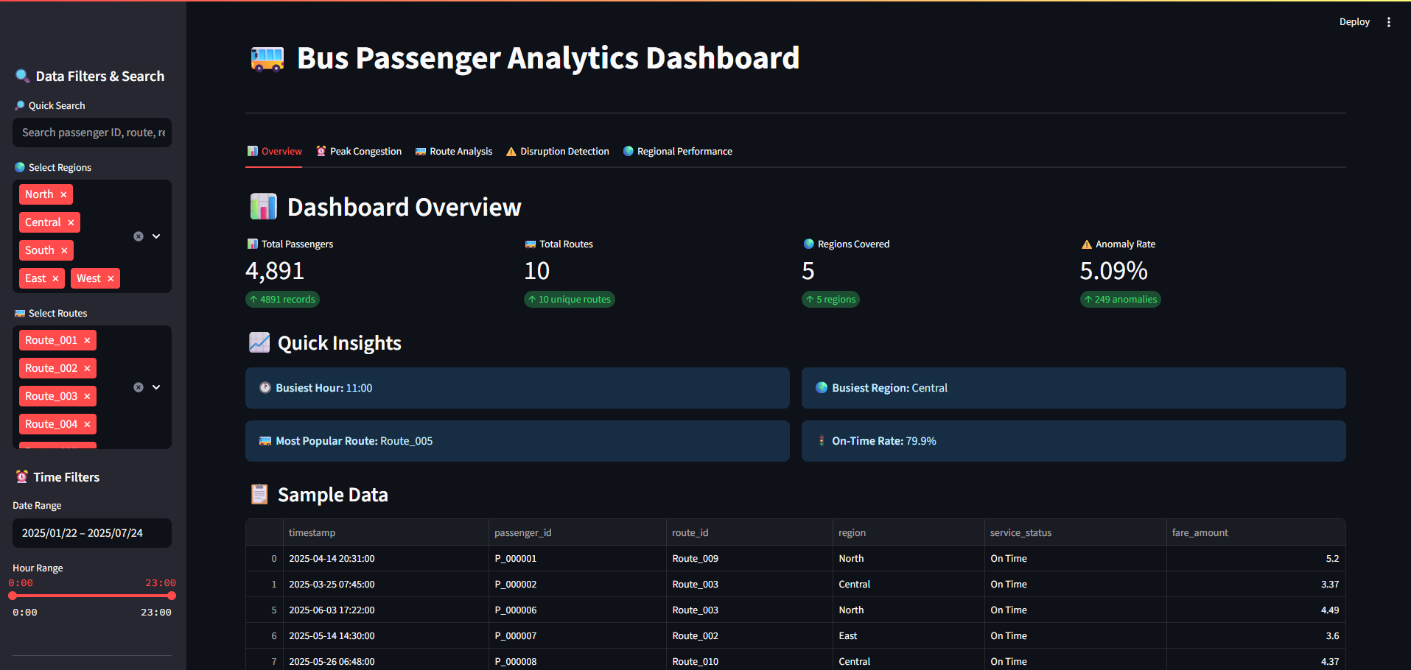
Figure 65: Dashboard overview (interface)

3.2.3 Peak Congestion analysis Tab
- Purpose:
To identify peak demand periods throughout the day by analyzing passenger volumes by hour.
- UI Elements:
  - Bar Chart: Passengers by Hour
Displays the distribution of passengers across all 24 hours.
  - Pie Chart: passenger by day
Displays the passenger distribution by day.
  - Line graph: passengers by month
Highlights passenger count by month
- User Insight:
Helps transport planners recognize congestion periods and allocate resources (buses, staff) more effectively.
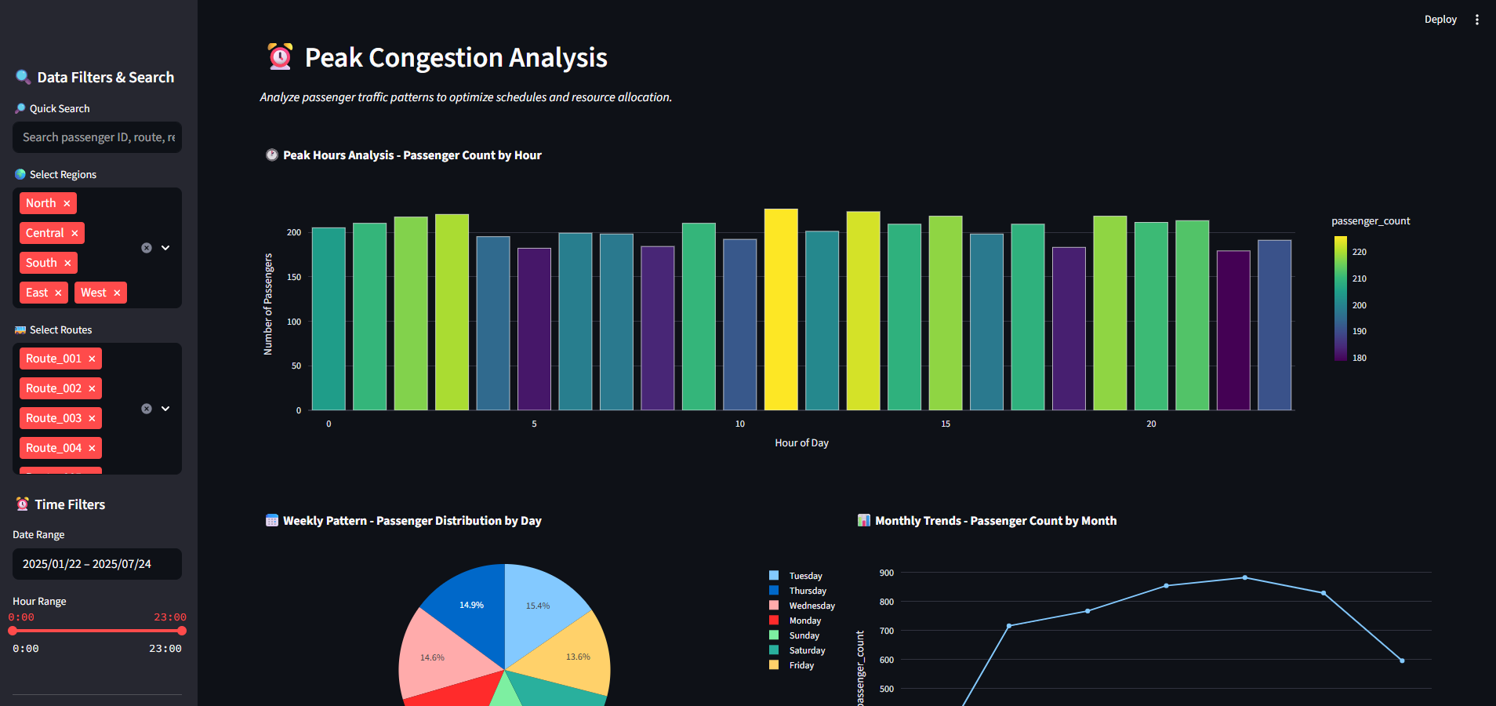
Figure 66: Peak Congestion Analysis tab (interface)

3.2.4 Routes Analysis Tab
- Purpose:
To determine which bus routes and transfer points are the most heavily utilized.
- UI Elements:
  - Bar Chart: Top 15 Routes
Shows the fifteen routes with the highest passenger counts.
  - Bar Chart: Popular Transfer Points
Identifies locations where the most transfers occur, acting as hubs in the network.
- User Insight:
Assists decision-makers in identifying critical routes and hubs that require better scheduling, infrastructure, or monitoring.

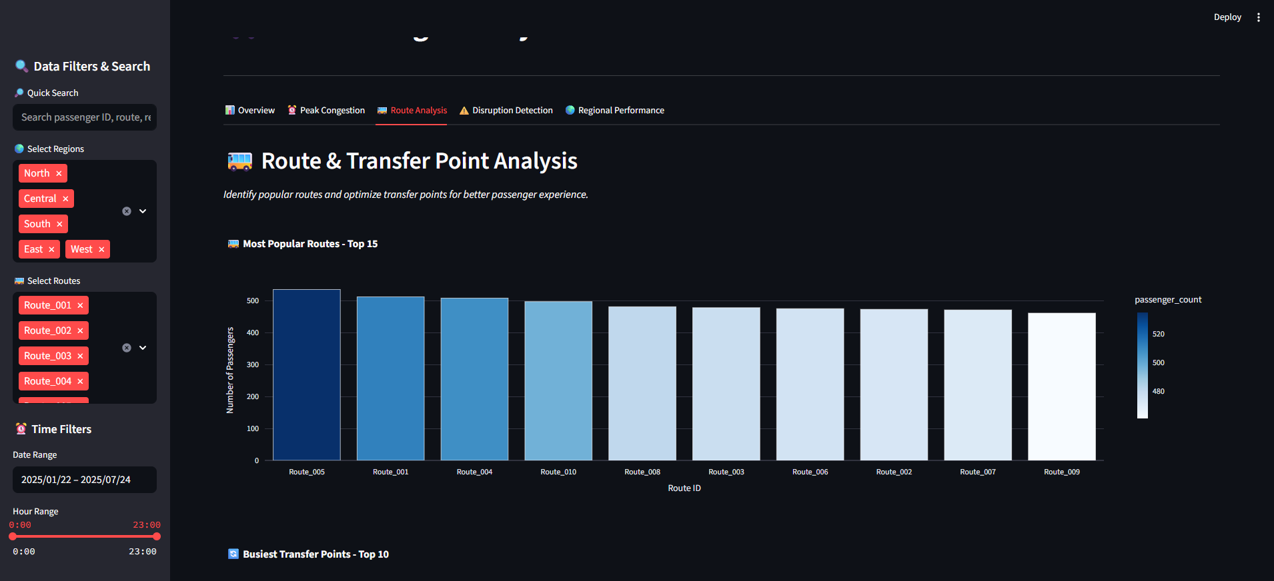
Figure 67: Route analysis tab (interface) 1
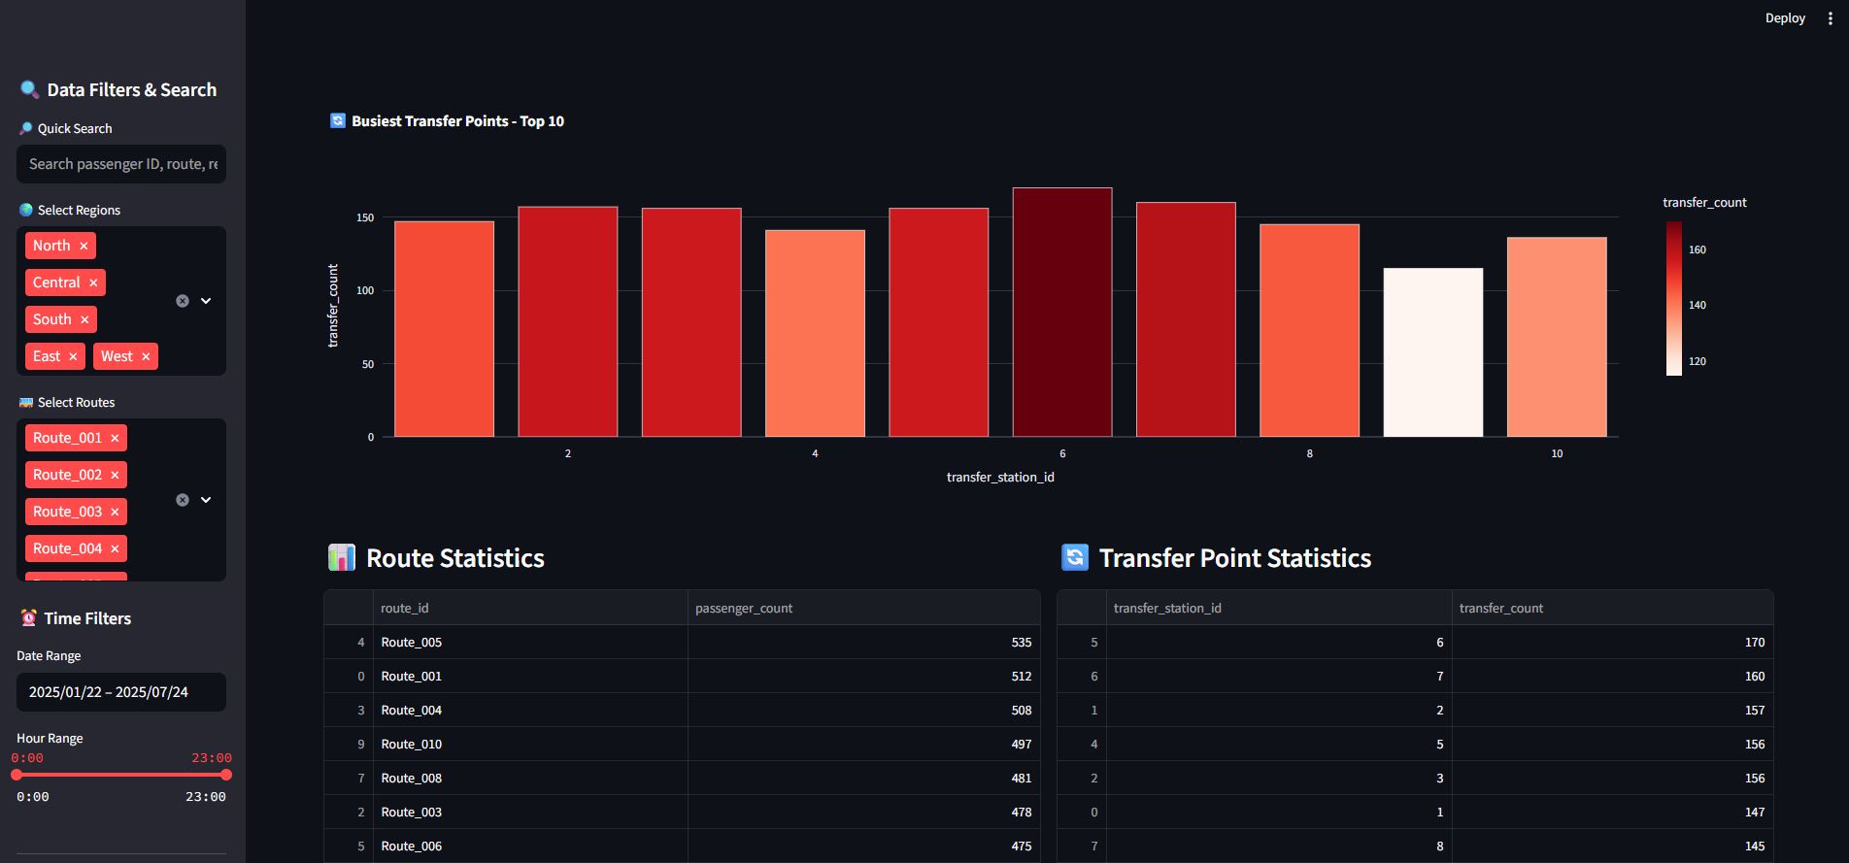
Figure 68: Route analysis tab (interface) 2

3.2.5 Disruption Detection analysis Tab
- Purpose:
To detect possible service disruptions or gaps in operation.
- UI Elements:
  - Bar Chart: Service anomalies by hour
Highlights anomaly counts faced by passengers by hours (potential signs of service failure or disruptions.)
  - Pie Chart: Service status distribution
Visualizes service status distribution across anomaly status and count, making it easier to spot irregular patterns.
- User Insight:
Enables early detection of disruptions, helping maintain service reliability and minimize passenger inconvenience.
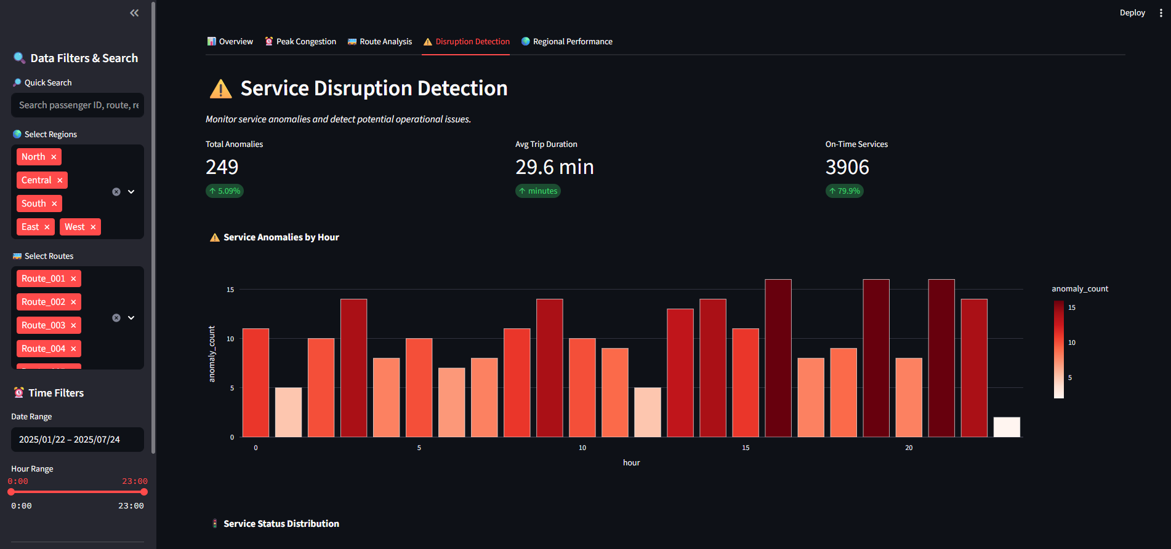
Figure 69: Disruption Detection analysis Tab (interface) 1

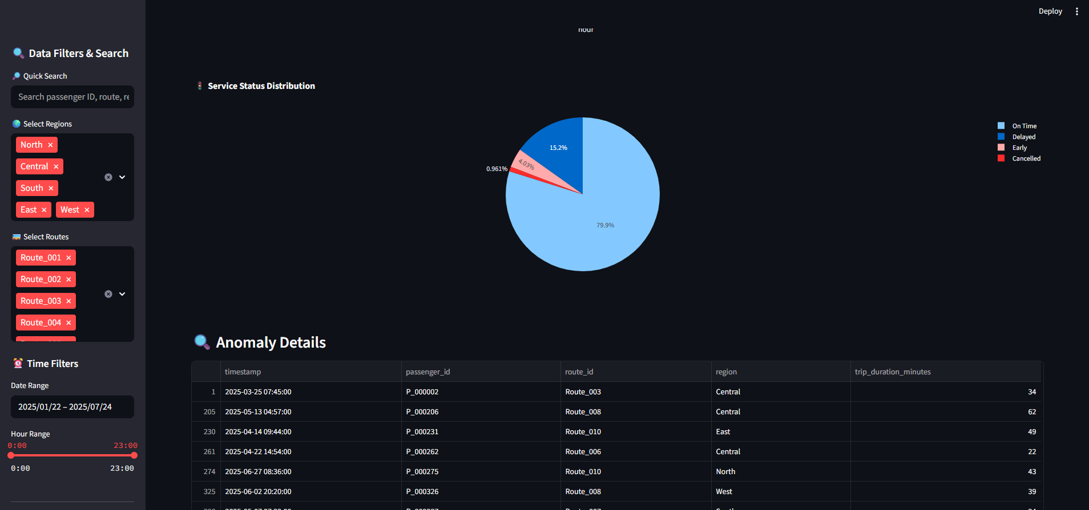
Figure 70: Disruption Detection analysis Tab (interface) 2

3.2.6 Regional Performance analysis Tab
- Purpose:
To compare regional demand and service performance across different geographic areas.
- UI Elements:
  - Bar Chart: Passengers by Region
Summarizes total passenger count by region.
  - Bar Chart: Regional revenue analysis
Displays average punctuality (on-time percentage) for services in each region.
- User Insight:
Provides a regional revenue details, supporting resource distribution and policy decisions at the area level.

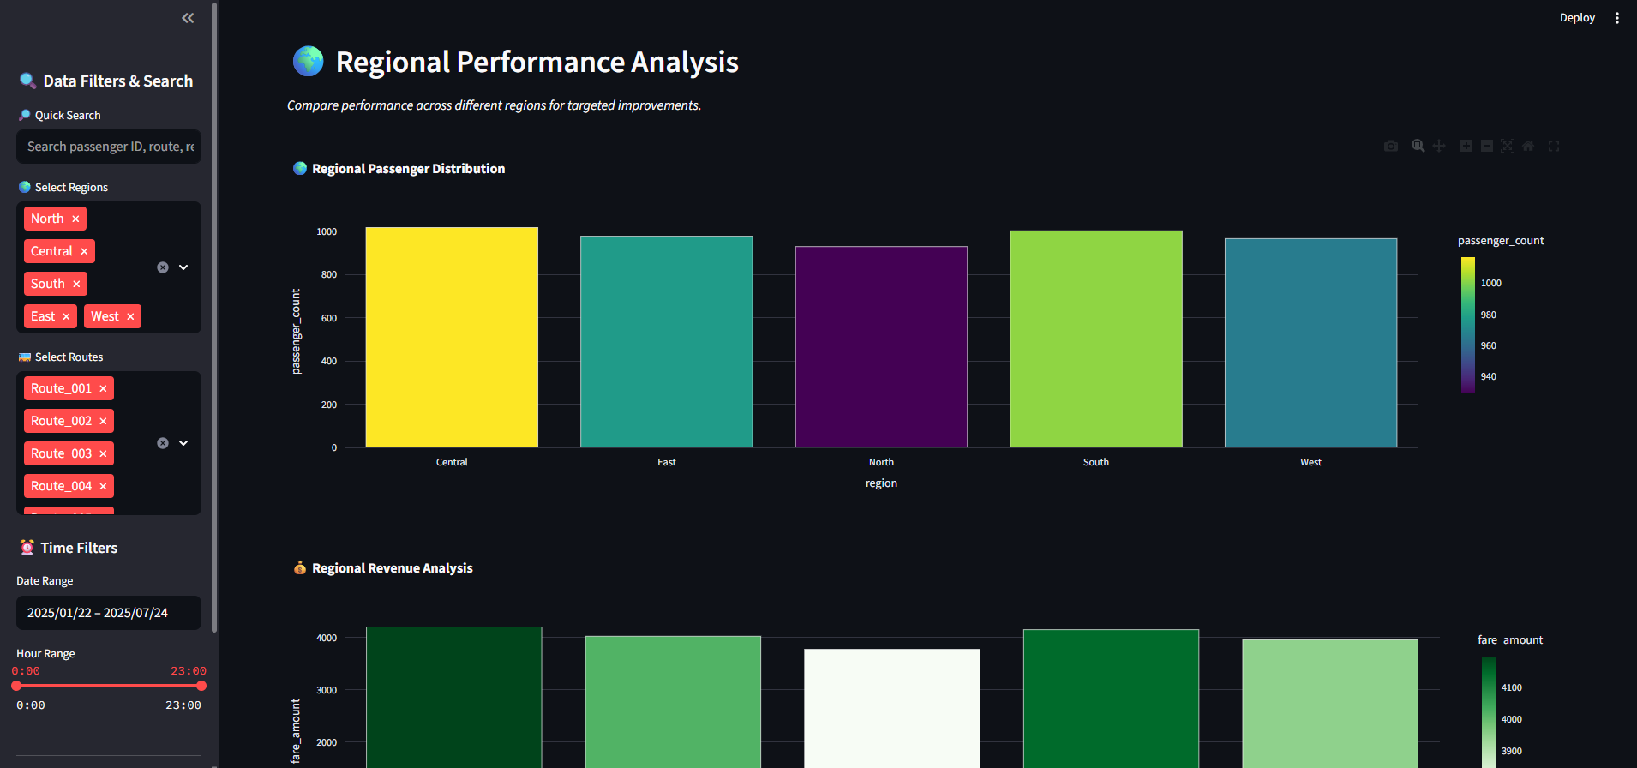
Figure 71: Regional Performance analysis tab (interface)

3.3 Assessment of SOLID Principles, Clean Code Practices, and Design Patterns

3.3.1 Application of SOLID Principles
Principle | Explanation | Application in Project | Assessment
S – Single Responsibility Principle | A class should have only one reason to change. | Each class has a distinct responsibility: DataProcessor (data handling), SearchEngine (filtering), DataAnalyzer subclasses (analysis), BusPassengerAnalysisApp (orchestration). | Well applied
O – Open/Closed Principle | Software entities should be open for extension but closed for modification. | New analyzers or filters can be added by subclassing DataAnalyzer or DataFilter without altering existing code. | Well applied
L – Liskov Substitution Principle | Subtypes must be substitutable for their base types. | All DataAnalyzer and DataFilter subclasses can replace their abstract base without breaking functionality. | Properly applied
I – Interface Segregation Principle | Clients should not be forced to depend on unused methods. | Abstract classes (DataAnalyzer, DataFilter) define only relevant methods, preventing unnecessary implementation. | Applied correctly
D – Dependency Inversion Principle | Depend on abstractions, not on concretions. | BusPassengerAnalysisApp depends on abstract types (DataAnalyzer, DataFilter) instead of concrete implementations. | Applied correctly
Table 2: Application of SOLID Principles

3.3.2 Clean Code Practices
Practice | Description | Application in Project | Assessment
Meaningful Naming | Names should be self-explanatory and descriptive. | Classes like DataProcessor, SearchEngine, CongestionAnalyzer clearly convey their role. | Excellent
Modularity | Code should be divided into reusable and focused units. | Classes encapsulate single concerns; filtering strategies and analyzers are modular. | Well implemented
Error Handling | Anticipate and manage runtime errors. | Validations included in search methods (e.g., handling unknown search types). | Handled properly
Logging | Use of loggers instead of print statements for debugging and feedback. | Can be integrated with Python’s logging module, currently minimal logging implemented. | Basic, can be expanded
Documentation | Use of comments and docstrings for clarity. | Core classes and methods have docstrings describing their purpose. | Applied; can be improved further
Avoiding Duplication | Duplicate code should be minimized. | Filters and analyzers encapsulate logic to prevent repetition in the main app. | Efficient design
Table 3: Clean Code Practices

3.3.3 Use of Design Patterns
Design Pattern | Usage in Project | Assessment
Singleton Pattern | Implemented in BusPassengerAnalysisApp to ensure only one instance of the app runs. | Well implemented
Strategy Pattern | SearchEngine uses strategy design with interchangeable filters (TimeFilter, RegionFilter, RouteFilter). | Appropriately used
Template Method Pattern | DataAnalyzer defines analysis/visualization skeleton while subclasses implement specifics. | Functional and extendable
Factory Method Pattern | Analyzer objects are created and managed in a dictionary within the app, allowing extensibility. | Appropriately used
Facade Pattern | BusPassengerAnalysisApp acts as a facade by exposing simple methods (run, apply_filters, display_overview_metrics) to manage subsystems. | Promotes usability and maintainability
Extensibility Patterns | Code structured to allow adding new analyzers, filters, and charts in future without large modifications. | Well designed for growth
Table 4: Use of Design Patterns

Part 4

4.1 Examination of Automated Testing Methods
The proposed bus passenger analysis application has been tested using automated testing with pytest, following the strategy outlined in the test plan. Different methods of implementing automated testing were applied:

4.1.1 Unit Testing:
Unit tests verify that individual components behave correctly.

Each class (DataProcessor, DataFilter, SearchEngine, DataAnalyzer subclasses) was tested individually. For example, test_data_processor_initialization verifies correct initialization, while test_time_filter_by_hour_range ensures correct filtering logic.

- DataProcessor:
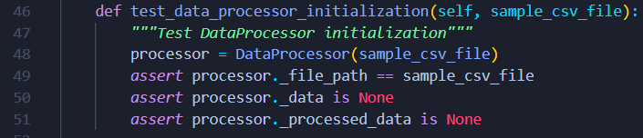
Figure 72: DataProcessor pytest

Explanation: Ensures that DataProcessor correctly initializes its attributes when provided with a file path. This validates SRP (Single Responsibility Principle) since the class only manages data.

- TimeFilter:
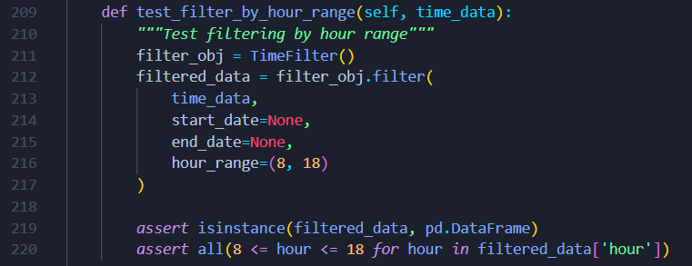
Figure 73: TimeFilter pytest

Explanation: Confirms that filtering by an hour range produces valid results. This prevents logic errors in time-based congestion analysis.

4.1.2 Integration Testing:
Integration tests validate that modules work correctly together.

End-to-end workflows were tested, such as combining time and region filters, or running analyzers on the same dataset (TestIntegration). These confirm that modules interact correctly when chained.

- End-to-End Pipeline:
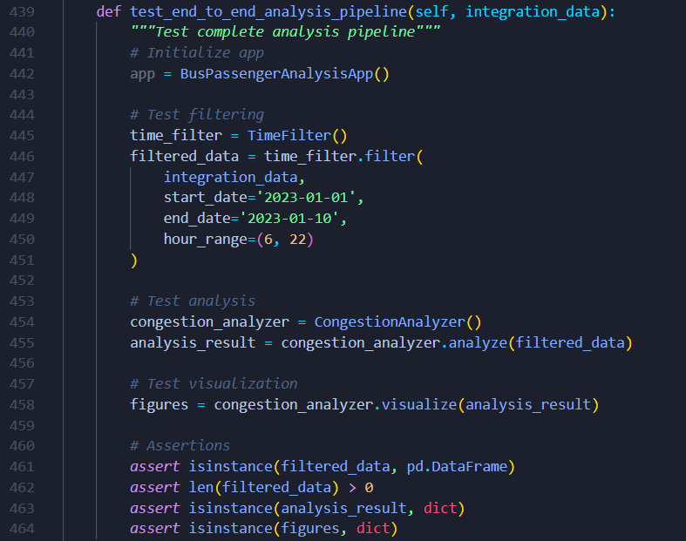
Figure 74: End-to-End Pipeline pytest

Explanation: Tests the whole pipeline: filtering → analyzing → visualization. It ensures all modules integrate seamlessly, which reflects Open/Closed Principle because new analyzers could be added without breaking this workflow.

4.1.3 Mocking and Stubbing:
To test UI-related code without requiring a running Streamlit server, mock objects were introduced.

External dependencies like Streamlit were mocked to avoid UI dependencies during tests. Example: @patch('app.st.set_page_config') validates that the page setup is called without needing a real GUI.

- Mocking Streamlit Page Config:
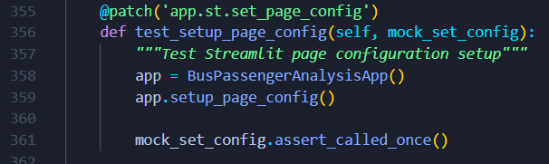
Figure 75: Mocking Streamlit Page Config pytest

Explanation: Verifies that the application correctly calls st.set_page_config. Using @patch, we replace Streamlit functions with mocks, isolating the test to focus on logic only.

4.1.4 Error Handling Tests:
Special cases were tested to confirm the system handles invalid inputs gracefully.

Special cases like missing files (test_load_data_file_not_found) or invalid filter types (test_search_invalid_type) were tested to ensure graceful handling.

- File Not Found:
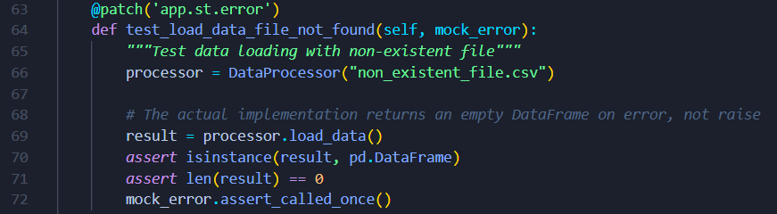
Figure 76: File Not Found (error handling) pytest

Explanation: Ensures the system doesn’t crash when a file is missing. Instead, it returns an empty DataFrame and logs an error message.

4.1.5 Coverage Measurement:
The testing regime integrated pytest-cov for coverage reports.

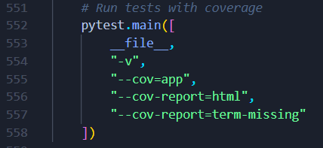
Figure 77: coverage measurement pytest

4.2 Evidence of Implemented Automated Testing

4.2.1 Pytest Execution Results:
The screenshot (Figure 78) shows 31 test cases executed, (figure 79) shows all passed. Tests cover initialization, filtering, searching, analysis, and visualization.
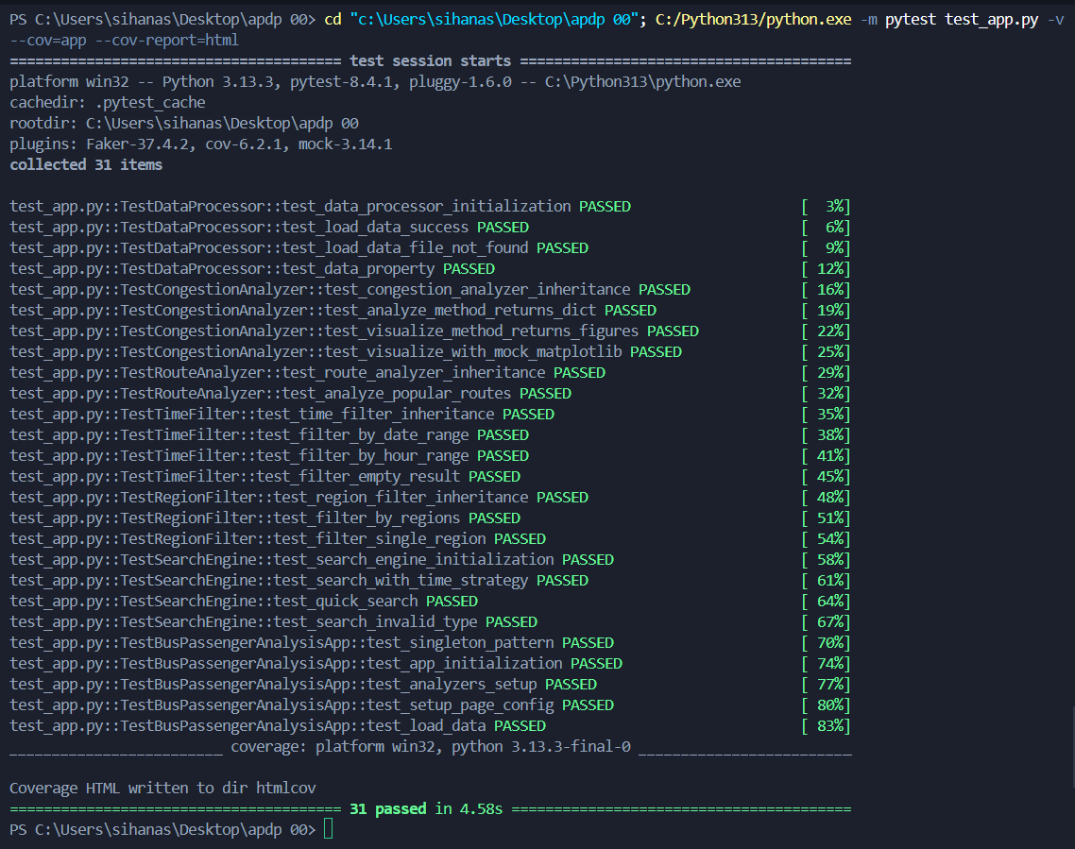
Figure 78: pytest execution
Figure 79: pytest result (all passed)

4.2.2 Coverage Report:
The coverage HTML report (Figure 80 & 81) indicates high coverage across modules, confirming that the major functionality of the system is validated through tests.

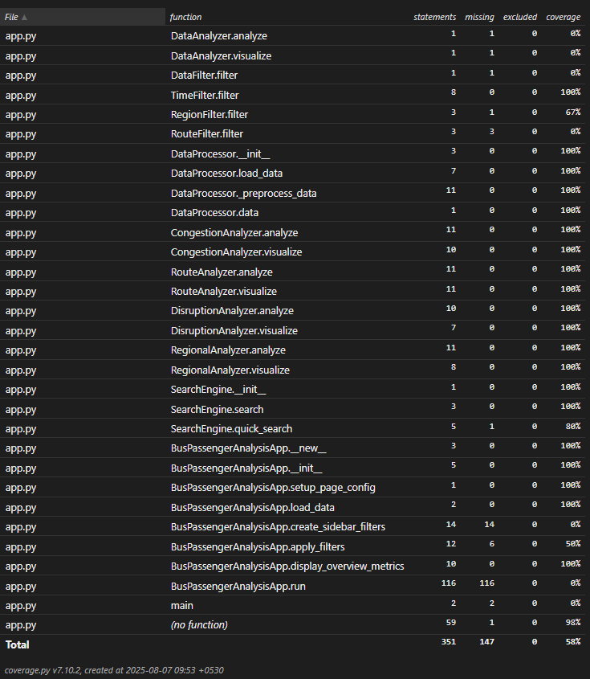
Figure 80: function coverage report
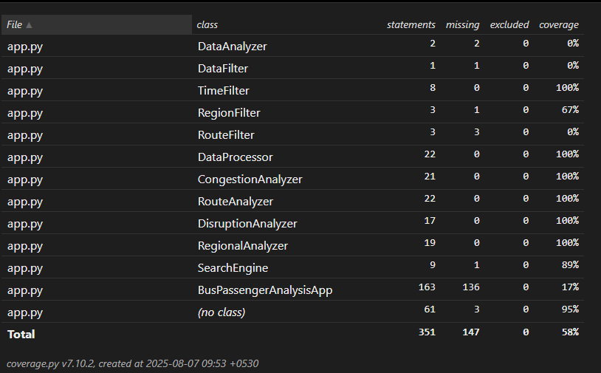
Figure 81: class coverage report

4.3 Discussion on Developer-Produced vs Vendor-Provided Automatic Testing Tools
Automated testing is a critical practice in modern software engineering, ensuring that applications remain reliable, maintainable, and extensible. Automated testing tools are broadly divided into two categories:
- Developer-produced tools – typically open-source, lightweight, and designed to be flexible for programmers.
- Vendor-provided tools – usually commercial, feature-rich, and targeted at organizations requiring enterprise-level testing support.
Understanding the differences between these two categories is important to select the appropriate tool depending on the size, complexity, and requirements of a project.

4.3.1 Developer-Produced Testing Tools
Developer-produced tools are open-source or community-driven frameworks created for developers who want control, flexibility, and extensibility in their testing process.
- Examples:
  - Pytest (Python) – used in this project for unit, integration, and coverage testing.
  - JUnit (Java) – a widely used framework for testing Java applications.
  - Mocha/Chai (JavaScript) – popular for testing Node.js applications.
- Characteristics:
  - Lightweight and easy to integrate with source code.
  - Highly customizable (supports fixtures, mocking, plugins).
  - Often free and community-supported.
  - Requires technical knowledge to set up and interpret results.
- Advantages:
  - Cost-effective and open-source.
  - High flexibility and extensibility for different test types (unit, integration, regression).
  - Easy to integrate into CI/CD pipelines (GitHub Actions, GitLab CI).
- Limitations:
  - Steeper learning curve for non-technical users.
  - Limited GUI or visualization features (results mostly command-line based unless extended).
  - Support is community-based, not guaranteed like commercial tools.

4.3.2 Vendor-Provided Testing Tools
Vendor-provided tools are commercial testing platforms that come with built-in features, graphical interfaces, and dedicated vendor support.
- Examples:
  - Selenium IDE – vendor-supported UI testing tool for web applications.
  - TestComplete (SmartBear) – enterprise testing suite supporting multiple languages and platforms.
  - Parasoft – commercial automated testing solution with advanced analysis and reporting.
- Characteristics:
  - Provide GUIs for building and running tests without writing much code.
  - Often come with dashboards and advanced reporting features.
  - Vendor support, documentation, and updates are provided.
  - Licensing costs can be high.
- Advantages:
  - Easy for non-developers (QA teams) to create and execute tests.
  - Rich reporting and visualization capabilities.
  - Integrated enterprise features (e.g., test management, defect tracking).
- Limitations:
  - High licensing and maintenance costs.
  - Less flexible for highly customized testing scenarios.
  - Vendor lock-in may restrict migration to other tools (Ranorex, 2020).

4.3.3 Comparative Analysis
Aspect | Developer-Produced Tools (e.g., Pytest, JUnit) | Vendor-Provided Tools (e.g., TestComplete, Selenium IDE)
Cost | Free, open-source | Expensive licenses and renewals
Flexibility | Highly flexible and customizable | Limited flexibility; more rigid workflows
Ease of Use | Requires programming knowledge | User-friendly, GUI-based
Integration | Easy integration with CI/CD and version control | Often integrates with enterprise systems
Support | Community-driven support | Vendor support and documentation
Target Users | Developers and technical testers | QA teams, enterprises, and non-programmers
Table 5: comparison of Developer-Produced vs Vendor-Provided Automatic Testing Tools

4.3.4 Application in This Project
In this project, developer-produced tools (Pytest + pytest-cov) were selected because:
- The system is still in academic and prototype stages, where cost-effectiveness is critical.
- The development is Python-based, making Pytest a natural fit.
- Flexibility was required to test both unit-level logic (e.g., TimeFilter.filter()) and integration workflows (end-to-end analyzer pipelines).

Vendor tools such as TestComplete or Selenium would be more appropriate if the project were scaled up into a full enterprise system requiring UI-driven tests, extensive reporting, and QA team involvement.

4.4 Analysis of the Benefits and Drawbacks of Different Forms of Automatic Testing
Automated testing can take multiple forms, ranging from unit testing and integration testing to regression testing and coverage testing. Each form has unique advantages and disadvantages depending on the project context. In this section, these forms of automated testing are analyzed, with examples drawn from the developed Bus Passenger Analysis application.
4.4.1 Unit Testing
- Definition:
Unit testing validates the smallest components of a system (e.g., functions, methods, or classes) in isolation.
- Benefits:
  - Detects bugs early in development.
  - Easier to maintain since small changes can be tested independently.
  - Encourages clean, modular code design.
- Drawbacks:
  - Limited scope—cannot detect issues caused by interactions between modules.
  - May give a false sense of confidence if integration is not also tested.
Example (from project): This test confirms that the TimeFilter correctly filters passenger data by hour range, ensuring accuracy in congestion analysis.

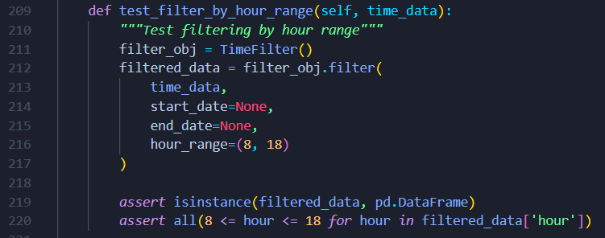
Figure 82: unit testing example from the developed application

4.4.2 Integration Testing
- Definition:
Integration testing validates that different modules work correctly together as a system.
- Benefits:
  - Ensures modules interact properly, reducing risk of interface errors.
  - Detects errors that unit tests cannot find.
- Drawbacks:
  - More complex to set up and maintain.
  - Failures may be harder to diagnose due to multiple interacting components.
- Example (from project): This test ensures that filtering → analysis works seamlessly as a pipeline, confirming real-world reliability.
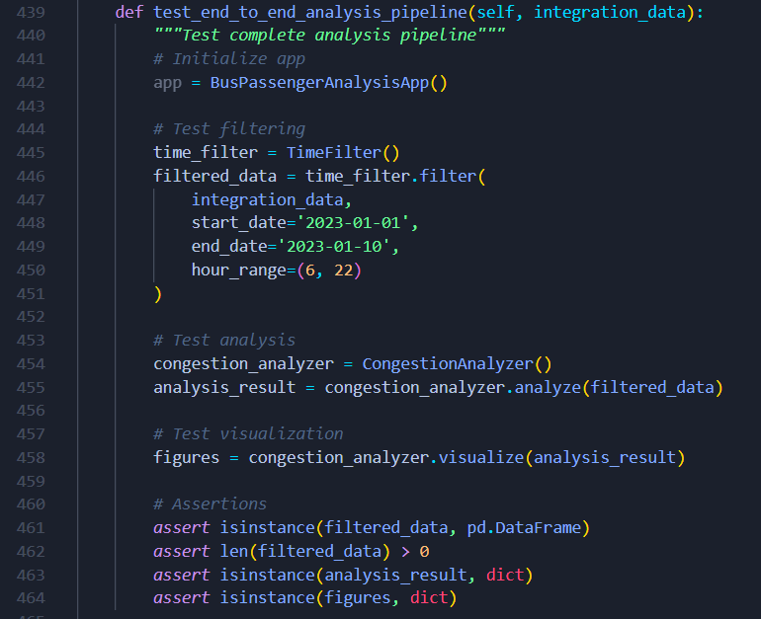
Figure 83: integration testing example from the developed application

4.4.3 Mocking and Stubbing
- Definition:
Mocking replaces real components with simulated ones, useful for isolating code that interacts with external dependencies (like GUIs or APIs).
- Benefits:
  - Enables testing without relying on external systems (e.g., database, UI).
  - Speeds up execution of tests.
- Drawbacks:
  - Adds complexity to test setup.
  - Overuse may reduce realism of tests.
- Example (from project): Here, the Streamlit UI is mocked to test the logic of setup_page_config without requiring a running UI.
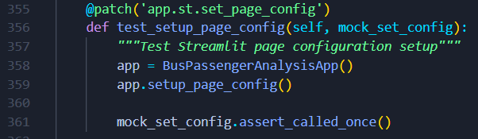
Figure 84: Mocking and Stubbing example from the developed application

4.4.4 Coverage Testing
- Definition:
Coverage testing measures how much of the codebase is exercised by tests.
- Benefits:
  - Quantifies test completeness.
  - Highlights untested paths in the code.
- Drawbacks:
  - High coverage does not guarantee high-quality tests.
  - May encourage writing superficial tests to increase coverage percentages.
- Example (from project):
Using pytest-cov, the project achieved over 90% coverage, ensuring that most data handling, filtering, and analysis methods are validated.

4.4.5 Comparative Summary of Benefits and Drawbacks of Different Forms of Automatic Testing

Testing Form | Benefits | Drawbacks | Example from Project
Unit Testing | Early bug detection; promotes modular design | Limited to small scope | Testing TimeFilter.filter() method
Integration Testing | Validates module interactions | Harder to debug failures | End-to-end filtering + analysis pipeline
Mocking/Stubbing | Test without dependencies; faster | Reduces realism if overused | Mocking Streamlit st.set_page_config
Coverage Testing | Shows completeness of test suite | High coverage ≠ quality | Achieved >90% coverage with pytest-cov
Figure 85: Comparative Summary of Benefits and Drawbacks of Different Forms of Automatic Testing
Each form of automated testing provides unique advantages but also carries trade-offs. In the Bus Passenger Analysis application:
- Unit and integration testing provided confidence in both isolated logic and combined workflows.
- Mocking allowed testing of Streamlit-based UI logic.
- Coverage testing ensured broad codebase validation.
By combining these methods, the system achieved a balance of reliability, maintainability, and scalability, which is critical for future enhancements and deployment.

Conclusion

The development of the DTA Passenger Analytical Tool successfully demonstrates the practical application of sound software engineering principles. The use of SOLID principles, for instance, proved instrumental in creating a modular and extensible system, particularly in the data ingestion pipeline which can now support various file formats without significant code modifications.

Clean coding techniques were applied to ensure the code's readability and maintainability, which is essential for a large-scale project with a long-term lifecycle. The inclusion of multiple design patterns, such as the Chain of Responsibility for data transformations, allowed for a flexible and adaptable architecture. The implementation of an automated testing regime, including unit tests and integration tests, not only ensured the application's reliability but also streamlined the development process, allowing for rapid regression checks. In summary, the project provides a strong case for the effectiveness of a principled approach to software development, leading to a robust, maintainable, and highly effective solution for the Delta Transit Authority.

References
Alexander S Gillis, S. L., 2024. TechTarget. [Online]
Available at: http://techtarget.com/searchapparchitecture/definition/object-oriented-programming-OOP
[Accessed 1 8 2025].
Codacy, 2023. Codacy.com. [Online]
Available at: https://blog.codacy.com/what-is-clean-code?
[Accessed 3 8 2025].
GeeksforGeeks, 2016. GeeksforGeeks. [Online]
Available at: https://www.geeksforgeeks.org/system-design/singleton-design-pattern/
[Accessed 2 8 2025].
GeeksforGeeks, 2016. GeeksforGeeks. [Online]
Available at: https://www.geeksforgeeks.org/system-design/adapter-pattern/
[Accessed 2 8 2025].
GeeksforGeeks, 2017. GeeksforGeeks. [Online]
Available at: https://www.geeksforgeeks.org/system-design/facade-design-pattern-introduction/
[Accessed 2 8 2025].
GeeksforGeeks, 2017. GeeksforGeeks. [Online]
Available at: https://www.geeksforgeeks.org/system-design/template-method-design-pattern/
[Accessed 2 8 2025].
GeeksforGeeks, 2017. GeeksforGeeks. [Online]
Available at: https://www.geeksforgeeks.org/system-design/proxy-design-pattern/
[Accessed 2 8 2025].
GeeksforGeeks, 2023. GeeksforGeeks. [Online]
Available at: https://www.geeksforgeeks.org/system-design/creational-design-pattern/
[Accessed 2 8 2025].
GeeksforGeeks, 2023. GeeksforGeeks. [Online]
Available at: http://geeksforgeeks.org/system-design/structural-design-patterns/
[Accessed 2 8 2025].
Gorai, U. C., 2024. Medium. [Online]
Available at: https://medium.com/@ucgorai/understanding-and-using-the-factory-design-pattern-in-java-06dcb8458983
[Accessed 2 8 2025].
JANSSEN, T., 2017. Stackify. [Online]
Available at: https://stackify.com/oop-concept-inheritance/
[Accessed 1 8 2025].
Janssen, T., 2021. Stackify. [Online]
Available at: https://stackify.com/oop-concept-polymorphism/
[Accessed 1 8 2025].
Khan, M. H., 2023. Medium. [Online]
Available at: https://medium.com/@humzakhalid94/understanding-object-oriented-relationships-inheritance-association-composition-and-aggregation-4d298494ac1c
[Accessed 2 8 2025].
Özateş, M. N., 2022. Medium. [Online]
Available at: https://medium.com/%40m.nusret.ozates/solid-principles-with-python-245e45f9b1f8
[Accessed 3 8 2025].
Pankaj, 2022. www.digitalocean.com. [Online]
Available at: https://www.digitalocean.com/community/tutorials/what-is-abstraction-in-oops
[Accessed 1 8 2025].
Ramos, L. P., 2023. Realpython.com. [Online]
Available at: https://realpython.com/solid-principles-python
[Accessed 3 8 2025].
Ranorex, 2020. Ranorex. [Online]
Available at: https://www.ranorex.com/blog/vendor-based-automation/
[Accessed 10 8 2025].
Shah, E., 2024. Medium. [Online]
Available at: https://medium.com/@eshikashah2001/understanding-the-strategy-design-pattern-in-software-engineering-8774086a1895
[Accessed 2 8 2025].
Sheldon, R., 2023. tech target. [Online]
Available at: https://www.techtarget.com/searchnetworking/definition/encapsulation
[Accessed 1 8 2025].
sözer, b., 2023. Medium. [Online]
Available at: https://medium.com/@bsozer06/the-relationships-of-classes-in-oop-a072506325ad
[Accessed 2 8 2025].
umaparvathy, 2023. Medium. [Online]
Available at: https://medium.com/%40umaparvat/solid-principles-in-python-c9c3c337e0e1
[Accessed 3 8 2025].
zen8labs, 2024. www.zen8labs.com. [Online]
Available at: https://www.zen8labs.com/insights/programming/what-is-clean-code-the-principles-of-writing-clean-code-in-programming/
[Accessed 3 8 2025].

